**AIRLINE RESERVATION SYSTEM**

**Mini Project**

Submitted in partial fulfillment of the requirement of University of Mumbai

For the Degree of

**(Computer Engineering)**

**By**

**1) Karishma Bairi ID No: TU3F1920014**

**2) Shweta Kaware ID NoTU3F1920005**

**3) Ketki Kulkarni ID No: TU3F1920053**

**4) Aman Lakhotra ID No: TU3F1920020**

**Under the Guidance of**

**Mrs. Ujwala Gaikwad**



**Department of Computer Engineering**

**TERNA ENGINEERING COLLEGE**

**Plot no.12, Sector-22, Opp. Nerul Railway station,**

**Phase-11, Nerul (w), Navi Mumbai 400706**

**UNIVERSITY OF MUMBAI**



**Terna Engineering College**

**NERUL, NAVI MUMBAI**

CERTIFICATE

*This is to certify that*

**1) Karishma Bairi ID No: TU3F1920014**

**2) Shweta Kaware ID NoTU3F1920005**

**3) Ketki Kulkarni ID No: TU3F1920053**

**4) Aman Lakhotra ID No: TU3F1920020**

*Has satisfactorily completed the requirements of the* ***Mini Project***

*Of subject*

**“Skill based Lab Course: Object Oriented Programming with Java”**

*As prescribed by the* ***University of Mumbai*** *Under the guidance of*

Prof. Mrs. **Ujwala Gaikwad**

**Subject Incharge HOD**

**Index**

**Chapter 1 Introduction .............................................................................4**

**Chapter 2 Problem Statement..................................................................5**

**Chapter 3 Implementation........................................................................6**

**Chapter 4 Conclusion.............................................................................75**

**Reference...............................................................................76**

**Chapter 1**

**Introduction**

In science and technology, the desire for development is a constant subject which triggers advancements. This is visible in every ramification or outcome and the airline industry is not an exemption. Airline reservation systems were first introduced in the late 1950s as comparatively simple standalone systems to control flight inventory, sustain flight schedules, seat assignments and aircraft loading. Today modern airline reservation systems are overall suites of products to provide systems that facilitate with a variety of airline management tasks and service customer needs from the time of initial reservation through finalization of the flight.

The World Wide Web has become tremendously popular over the last four years, and presently most of the airlines have made amenities for online reservation of their flights. The Internet has become a major resource for people looking for making reservations online without the inconvenience of meeting travel agents by implementing an online reservation system, this confirms that reservations are not only generated or produced by the airline own staff but also by any travel agent using a Global Distribution system or other airlines that have a multifaceted Interline Traffic Agreement with the airline.

A Computer Reservations System is a computerized system used to store and retrieve/recover information and conduct transactions related to travel. Computer reservation systems are classified as Passenger Service Systems (PSS) which controls a series of critical functions for the airline. Considering an Airline, the reservation system is a mission critical system that should use the latest state of the art technology to provide for all flight reservations on a vigorous or robust platform, which is flexible and can be adapted or adjusted to any style of airline. Secure and stable systems are of utmost importance to the airline industry which is why companies spend many years crafting an architecture specifically suited to the nature of the airline industry which often require tens of thousands of users to access and use the system simultaneously.

**Chapter 2**

**Problem Statement**

Normally a person wants to reserve his ticket and he has to contact at nearest Overseas Travels branch. The Airline Reservation System provides an interface to schedule flights and reservations for an airline through internet. Its responsibility is to keep track of system users, customers, Airbus information, flight information and cancellation.

The current system is manual, this system is slow, time consuming and it is very difficult for each person to book through office agents. Users inquire about the tickets through phones and it is very difficult for the user to remember all the details that they received through phones. It is very difficult to calculate how many people registered and how many seats on a particular plane are vacant .This requires quite a lot of time and wastage of money as it requires quite lot of manpower to do.

**Chapter 3**

**Implementation**

**CODE:**

import java.sql.Connection;

import java.sql.DriverManager;

import java.sql.PreparedStatement;

import java.sql.ResultSet;

import java.sql.SQLException;

import java.util.logging.Level;

import java.util.logging.Logger;

import javax.swing.JOptionPane;

/*

* To change this license header, choose License Headers in Project Properties.

* To change this template file, choose Tools | Templates

* and open the template in the editor.

*/

/**

*

* @author kobinath

*/

public class Login extends javax.swing.JFrame {

/**

* Creates new form Login

*/

public Login() {

initComponents();

}

Connection con;

PreparedStatement pst;

/**

* This method is called from within the constructor to initialize the form.

* WARNING: Do NOT modify this code. The content of this method is always

* regenerated by the Form Editor.

*/

@SuppressWarnings("unchecked")

// <editor-fold defaultstate="collapsed" desc="Generated Code">

private void initComponents() {

jPanel1 = new javax.swing.JPanel();

jLabel1 = new javax.swing.JLabel();

jLabel2 = new javax.swing.JLabel();

jButton1 = new javax.swing.JButton();

jButton2 = new javax.swing.JButton();

txtuser = new javax.swing.JTextField();

txtpass = new javax.swing.JPasswordField();

etDefaultCloseOperation(javax.swing.WindowConstants.EXIT_ON_CLOSE);

jPanel1.setBorder(javax.swing.BorderFactory.createTitledBorder(null, "Login", javax.swing.border.TitledBorder.DEFAULT_JUSTIFICATION, javax.swing.border.TitledBorder.DEFAULT_POSITION, new java.awt.Font("Tahoma", 1, 18))); // NOI18N

jLabel1.setText("UserName");

jLabel2.setText("Password");

jButton1.setText("Login");

jButton1.addActionListener(new java.awt.event.ActionListener() {

public void actionPerformed(java.awt.event.ActionEvent evt) {

jButton1ActionPerformed(evt);

}

});

jButton2.setText("Cancel");

txtuser.setText("john");

javax.swing.GroupLayout jPanel1Layout = new javax.swing.GroupLayout(jPanel1);

jPanel1.setLayout(jPanel1Layout);

jPanel1Layout.setHorizontalGroup( jPanel1Layout.createParallelGroup(javax.swing.GroupLayout.Alignment.LEADING)

.addGroup(jPanel1Layout.createSequentialGroup() .addGroup(jPanel1Layout.createParallelGroup(javax.swing.GroupLayout.Alignment.LEADING)

.addGroup(jPanel1Layout.createSequentialGroup()

.addGap(50, 50, 50)

.addGroup(jPanel1Layout.createParallelGroup(javax.swing.GroupLayout.Alignment.LEADING)

.addComponent(jLabel1)

.addComponent(jLabel2))

.addGap(52, 52, 52)

.addGroup(jPanel1Layout.createParallelGroup(javax.swing.GroupLayout.Alignment.LEADING, false)

.addComponent(txtuser)

.addComponent(txtpass, javax.swing.GroupLayout.DEFAULT_SIZE, 177, Short.MAX_VALUE)))

.addGroup(jPanel1Layout.createSequentialGroup()

.addGap(136, 136, 136)

.addComponent(jButton1, javax.swing.GroupLayout.PREFERRED_SIZE, 97, javax.swing.GroupLayout.PREFERRED_SIZE)

.addGap(18, 18, 18)

.addComponent(jButton2, javax.swing.GroupLayout.PREFERRED_SIZE, 116, javax.swing.GroupLayout.PREFERRED_SIZE)))

.addContainerGap(25, Short.MAX_VALUE))

);

jPanel1Layout.setVerticalGroup(

jPanel1Layout.createParallelGroup(javax.swing.GroupLayout.Alignment.LEADING)

.addGroup(jPanel1Layout.createSequentialGroup()

.addGap(46, 46, 46)

.addGroup(jPanel1Layout.createParallelGroup(javax.swing.GroupLayout.Alignment.BASELINE)

.addComponent(jLabel1)

.addComponent(txtuser, javax.swing.GroupLayout.PREFERRED_SIZE, javax.swing.GroupLayout.DEFAULT_SIZE, javax.swing.GroupLayout.PREFERRED_SIZE))

.addGap(43, 43, 43) .addGroup(jPanel1Layout.createParallelGroup(javax.swing.GroupLayout.Alignment.BASELINE)

.addComponent(jLabel2)

.addComponent(txtpass, javax.swing.GroupLayout.PREFERRED_SIZE, javax.swing.GroupLayout.DEFAULT_SIZE, javax.swing.GroupLayout.PREFERRED_SIZE)) .addPreferredGap(javax.swing.LayoutStyle.ComponentPlacement.RELATED, 31, Short.MAX_VALUE) .addGroup(jPanel1Layout.createParallelGroup(javax.swing.GroupLayout.Alignment.BASELINE)

.addComponent(jButton1, javax.swing.GroupLayout.PREFERRED_SIZE, 39, javax.swing.GroupLayout.PREFERRED_SIZE)

.addComponent(jButton2, javax.swing.GroupLayout.PREFERRED_SIZE, 36, javax.swing.GroupLayout.PREFERRED_SIZE))

.addGap(45, 45, 45))

);

javax.swing.GroupLayout layout = new javax.swing.GroupLayout(getContentPane());

getContentPane().setLayout(layout);

layout.setHorizontalGroup(

layout.createParallelGroup(javax.swing.GroupLayout.Alignment.LEADING)

.addGroup(layout.createSequentialGroup()

.addGap(26, 26, 26)

.addComponent(jPanel1, javax.swing.GroupLayout.PREFERRED_SIZE, javax.swing.GroupLayout.DEFAULT_SIZE, javax.swing.GroupLayout.PREFERRED_SIZE)

.addContainerGap(44, Short.MAX_VALUE))

);

layout.setVerticalGroup(

layout.createParallelGroup(javax.swing.GroupLayout.Alignment.LEADING)

.addGroup(layout.createSequentialGroup()

.addGap(30, 30, 30)

.addComponent(jPanel1, javax.swing.GroupLayout.PREFERRED_SIZE, javax.swing.GroupLayout.DEFAULT_SIZE, javax.swing.GroupLayout.PREFERRED_SIZE)

.addContainerGap(22, Short.MAX_VALUE))

);

pack();

setLocationRelativeTo(null);

}// </editor-fold>

private void jButton1ActionPerformed(java.awt.event.ActionEvent evt) {

// TODO add your handling code here:

String username = txtuser.getText();

String password = txtpass.getText();

if(username.isEmpty() || password.isEmpty())

{

JOptionPane.showMessageDialog(this, "UserName or Password Blank");

}

else

{

try {

Class.forName("com.mysql.jdbc.Driver");

con = DriverManager.getConnection("jdbc:mysql://localhost/airline0","root","");

pst = con.prepareStatement("select * from user where username = ? and password = ?");

pst.setString(1, username);

pst.setString(2, password);

ResultSet rs;

rs = pst.executeQuery();

if(rs.next())

{

Main m = new Main();

this.hide();

m.setVisible(true);

}

else

{

JOptionPane.showMessageDialog(this, "UserName or Password do not Match");

txtuser.setText("");

txtpass.setText("");

txtuser.requestFocus();

}

} catch (ClassNotFoundException ex) {

Logger.getLogger(Login.class.getName()).log(Level.SEVERE, null, ex);

} catch (SQLException ex) {

Logger.getLogger(Login.class.getName()).log(Level.SEVERE, null, ex);

}

}

}

/**

* @param args the command line arguments

*/

public static void main(String args[]) {

/* Set the Nimbus look and feel */

//<editor-fold defaultstate="collapsed" desc=" Look and feel setting code (optional) ">

/* If Nimbus (introduced in Java SE 6) is not available, stay with the default look and feel.

* For details see http://download.oracle.com/javase/tutorial/uiswing/lookandfeel/plaf.html

*/

try {

for (javax.swing.UIManager.LookAndFeelInfo info : javax.swing.UIManager.getInstalledLookAndFeels()) {

if ("Nimbus".equals(info.getName())) {

javax.swing.UIManager.setLookAndFeel(info.getClassName());

break;

}

}

} catch (ClassNotFoundException ex) { java.util.logging.Logger.getLogger(Login.class.getName()).log(java.util.logging.Level.SEVERE, null, ex);

} catch (InstantiationException ex) {

java.util.logging.Logger.getLogger(Login.class.getName()).log(java.util.logging.Level.SEVERE, null, ex);

} catch (IllegalAccessException ex) { java.util.logging.Logger.getLogger(Login.class.getName()).log(java.util.logging.Level.SEVERE, null, ex);

} catch (javax.swing.UnsupportedLookAndFeelException ex) { java.util.logging.Logger.getLogger(Login.class.getName()).log(java.util.logging.Level.SEVERE, null, ex);

}

//</editor-fold>

/* Create and display the form */

java.awt.EventQueue.invokeLater(new Runnable() {

public void run() {

new Login().setVisible(true);

}

});

}

// Variables declaration - do not modify

private javax.swing.JButton jButton1;

private javax.swing.JButton jButton2;

private javax.swing.JLabel jLabel1;

private javax.swing.JLabel jLabel2;

private javax.swing.JPanel jPanel1;

private javax.swing.JPasswordField txtpass;

private javax.swing.JTextField txtuser;

// End of variables declaration

}

*

* To change this license header, choose License Headers in Project Properties.

* To change this template file, choose Tools | Templates

* and open the template in the editor.

*/

/**

*

* @author kobinath

*/

public class Main extends javax.swing.JFrame {

/**

* Creates new form Main

*/

public Main() {

initComponents();

}

/**

* This method is called from within the constructor to initialize the form.

* WARNING: Do NOT modify this code. The content of this method is always

* regenerated by the Form Editor.

*/

@SuppressWarnings("unchecked")

// <editor-fold defaultstate="collapsed" desc="Generated Code">

private void initComponents() {

jDesktopPane1 = new javax.swing.JDesktopPane();

jMenuBar1 = new javax.swing.JMenuBar();

jMenu1 = new javax.swing.JMenu();

jMenuItem1 = new javax.swing.JMenuItem();

jMenuItem2 = new javax.swing.JMenuItem();

jMenu2 = new javax.swing.JMenu();

jMenuItem3 = new javax.swing.JMenuItem();

jMenuItem6 = new javax.swing.JMenuItem();

jMenu3 = new javax.swing.JMenu();

jMenuItem4 = new javax.swing.JMenuItem();

jMenu4 = new javax.swing.JMenu();

jMenuItem5 = new javax.swing.JMenuItem();

setDefaultCloseOperation(javax.swing.WindowConstants.EXIT_ON_CLOSE);

setPreferredSize(new java.awt.Dimension(1366, 768));

javax.swing.GroupLayout jDesktopPane1Layout = new javax.swing.GroupLayout(jDesktopPane1);

jDesktopPane1.setLayout(jDesktopPane1Layout);

jDesktopPane1Layout.setHorizontalGroup( jDesktopPane1Layout.createParallelGroup(javax.swing.GroupLayout.Alignment.LEADING)

.addGap(0, 400, Short.MAX_VALUE)

);

jDesktopPane1Layout.setVerticalGroup( jDesktopPane1Layout.createParallelGroup(javax.swing.GroupLayout.Alignment.LEADING)

.addGap(0, 279, Short.MAX_VALUE)

);

jMenu1.setText("Customer");

jMenuItem1.setText("Add Customer");

jMenuItem1.addActionListener(new java.awt.event.ActionListener() {

public void actionPerformed(java.awt.event.ActionEvent evt) {

jMenuItem1ActionPerformed(evt);

}

});

jMenu1.add(jMenuItem1);

jMenuItem2.setText("Search Customer");

jMenuItem2.addActionListener(new java.awt.event.ActionListener() {

public void actionPerformed(java.awt.event.ActionEvent evt) {

jMenuItem2ActionPerformed(evt);

}

});

jMenu1.add(jMenuItem2);

jMenuBar1.add(jMenu1);

jMenu2.setText("Tickets");

jMenuItem3.setText("Book Ticket");

jMenuItem3.addActionListener(new java.awt.event.ActionListener() {

public void actionPerformed(java.awt.event.ActionEvent evt) {

jMenuItem3ActionPerformed(evt);

}

});

jMenu2.add(jMenuItem3);

jMenuItem6.setText("Ticket Report");

jMenuItem6.addActionListener(new java.awt.event.ActionListener() {

public void actionPerformed(java.awt.event.ActionEvent evt) {

jMenuItem6ActionPerformed(evt);

}

});

jMenu2.add(jMenuItem6);

jMenuBar1.add(jMenu2);

jMenu3.setText("Flight");

jMenuItem4.setText("Add Flight");

jMenuItem4.addActionListener(new java.awt.event.ActionListener() {

public void actionPerformed(java.awt.event.ActionEvent evt) {

jMenuItem4ActionPerformed(evt);

}

});

jMenu3.add(jMenuItem4);

jMenuBar1.add(jMenu3);

jMenu4.setText("User");

jMenuItem5.setText("UserCreation");

jMenuItem5.addActionListener(new java.awt.event.ActionListener() {

public void actionPerformed(java.awt.event.ActionEvent evt) {

jMenuItem5ActionPerformed(evt);

}

});

jMenu4.add(jMenuItem5);

jMenuBar1.add(jMenu4);

setJMenuBar(jMenuBar1);

javax.swing.GroupLayout layout = new javax.swing.GroupLayout(getContentPane());

getContentPane().setLayout(layout);

layout.setHorizontalGroup(

layout.createParallelGroup(javax.swing.GroupLayout.Alignment.LEADING)

.addComponent(jDesktopPane1)

);

layout.setVerticalGroup(

layout.createParallelGroup(javax.swing.GroupLayout.Alignment.LEADING)

.addComponent(jDesktopPane1)

);

pack();

}// </editor-fold>

private void jMenuItem1ActionPerformed(java.awt.event.ActionEvent evt) {

// TODO add your handling code here:

addCustomer cus = new addCustomer();

jDesktopPane1.add(cus);

cus.setVisible(true);

}

private void jMenuItem2ActionPerformed(java.awt.event.ActionEvent evt) {

// TODO add your handling code here:

searchCustomer scus = new searchCustomer();

jDesktopPane1.add(scus);

scus.setVisible(true);

}

private void jMenuItem4ActionPerformed(java.awt.event.ActionEvent evt) {

// TODO add your handling code here:

addflight f = new addflight();

jDesktopPane1.add(f);

f.setVisible(true);

}

private void jMenuItem3ActionPerformed(java.awt.event.ActionEvent evt) {

// TODO add your handling code here:

ticket t = new ticket();

jDesktopPane1.add(t);

t.setVisible(true);

}

private void jMenuItem6ActionPerformed(java.awt.event.ActionEvent evt) {

// TODO add your handling code here:

ticketreport ti = new ticketreport();

jDesktopPane1.add(ti);

ti.setVisible(true);

}

private void jMenuItem5ActionPerformed(java.awt.event.ActionEvent evt) {

// TODO add your handling code here:

userCreation u = new userCreation();

jDesktopPane1.add(u);

u.setVisible(true);

}

/**

* @param args the command line arguments

*/

public static void main(String args[]) {

/* Set the Nimbus look and feel */

//<editor-fold defaultstate="collapsed" desc=" Look and feel setting code (optional) ">

/* If Nimbus (introduced in Java SE 6) is not available, stay with the default look and feel.

* For details see http://download.oracle.com/javase/tutorial/uiswing/lookandfeel/plaf.html

*/

try {

for (javax.swing.UIManager.LookAndFeelInfo info : javax.swing.UIManager.getInstalledLookAndFeels()) {

if ("Nimbus".equals(info.getName())) {

javax.swing.UIManager.setLookAndFeel(info.getClassName());

break;

}

}

} catch (ClassNotFoundException ex) { java.util.logging.Logger.getLogger(Main.class.getName()).log(java.util.logging.Level.SEVERE, null, ex);

} catch (InstantiationException ex) { java.util.logging.Logger.getLogger(Main.class.getName()).log(java.util.logging.Level.SEVERE, null, ex);

} catch (IllegalAccessException ex) { java.util.logging.Logger.getLogger(Main.class.getName()).log(java.util.logging.Level.SEVERE, null, ex);

} catch (javax.swing.UnsupportedLookAndFeelException ex) { java.util.logging.Logger.getLogger(Main.class.getName()).log(java.util.logging.Level.SEVERE, null, ex);

}

//</editor-fold>

/* Create and display the form */

java.awt.EventQueue.invokeLater(new Runnable() {

public void run() {

new Main().setVisible(true);

}

});

}

// Variables declaration - do not modify

private javax.swing.JDesktopPane jDesktopPane1;

private javax.swing.JMenu jMenu1;

private javax.swing.JMenu jMenu2;

private javax.swing.JMenu jMenu3;

private javax.swing.JMenu jMenu4;

private javax.swing.JMenuBar jMenuBar1;

private javax.swing.JMenuItem jMenuItem1;

private javax.swing.JMenuItem jMenuItem2;

private javax.swing.JMenuItem jMenuItem3;

private javax.swing.JMenuItem jMenuItem4;

private javax.swing.JMenuItem jMenuItem5;

private javax.swing.JMenuItem jMenuItem6;

// End of variables declaration

}

import java.awt.Image;

import java.awt.image.BufferedImage;

import java.io.ByteArrayOutputStream;

import java.io.File;

import java.io.FileInputStream;

import java.io.IOException;

import java.sql.Connection;

import java.sql.DriverManager;

import java.sql.PreparedStatement;

import java.sql.ResultSet;

import java.sql.SQLException;

import java.sql.Statement;

import java.text.DateFormat;

import java.text.SimpleDateFormat;

import java.util.logging.Level;

import java.util.logging.Logger;

import javax.imageio.ImageIO;

import javax.swing.ImageIcon;

import javax.swing.JFileChooser;

import javax.swing.JOptionPane;

import javax.swing.filechooser.FileNameExtensionFilter;

/*

* To change this license header, choose License Headers in Project Properties.

* To change this template file, choose Tools | Templates

* and open the template in the editor.

*/

/**

*

* @author kobinath

*/

public class addCustomer extends javax.swing.JInternalFrame {

/**

* Creates new form addCustomer

*/

public addCustomer() {

initComponents();

autoID();

}

Connection con;

PreparedStatement pst;

String path=null;

byte[] userimage=null;

/**

* This method is called from within the constructor to initialize the form.

* WARNING: Do NOT modify this code. The content of this method is always

* regenerated by the Form Editor.

*/

@SuppressWarnings("unchecked")

// <editor-fold defaultstate="collapsed" desc="Generated Code">

private void initComponents() {

jPanel1 = new javax.swing.JPanel();

jLabel1 = new javax.swing.JLabel();

jLabel2 = new javax.swing.JLabel();

jLabel3 = new javax.swing.JLabel();

jLabel4 = new javax.swing.JLabel();

jLabel5 = new javax.swing.JLabel();

txtlastname = new javax.swing.JTextField();

txtfirstname = new javax.swing.JTextField();

txtnic = new javax.swing.JTextField();

txtpassport = new javax.swing.JTextField();

jScrollPane1 = new javax.swing.JScrollPane();

txtaddress = new javax.swing.JTextArea();

jLabel6 = new javax.swing.JLabel();

txtid = new javax.swing.JLabel();

jPanel2 = new javax.swing.JPanel();

jLabel8 = new javax.swing.JLabel();

jLabel9 = new javax.swing.JLabel();

jLabel10 = new javax.swing.JLabel();

txtdob = new com.toedter.calendar.JDateChooser();

r1 = new javax.swing.JRadioButton();

r2 = new javax.swing.JRadioButton();

txtcontact = new javax.swing.JTextField();

txtphoto = new javax.swing.JLabel();

jButton1 = new javax.swing.JButton();

jButton2 = new javax.swing.JButton();

jButton3 = new javax.swing.JButton();

jPanel1.setBackground(new java.awt.Color(51, 0, 255));

jLabel1.setFont(new java.awt.Font("Tahoma", 1, 11)); // NOI18N

jLabel1.setForeground(new java.awt.Color(255, 255, 255));

jLabel1.setText("FirstName");

jLabel2.setFont(new java.awt.Font("Tahoma", 1, 11)); // NOI18N

jLabel2.setForeground(new java.awt.Color(255, 255, 255));

jLabel2.setText("LastName");

jLabel3.setFont(new java.awt.Font("Tahoma", 1, 11)); // NOI18N

jLabel3.setForeground(new java.awt.Color(255, 255, 255));

jLabel3.setText("Nic No");

jLabel4.setFont(new java.awt.Font("Tahoma", 1, 11)); // NOI18N

jLabel4.setForeground(new java.awt.Color(255, 255, 255));

jLabel4.setText("Passport ID");

jLabel5.setFont(new java.awt.Font("Tahoma", 1, 11)); // NOI18N

jLabel5.setForeground(new java.awt.Color(255, 255, 255));

jLabel5.setText("Address");

txtlastname.addActionListener(new java.awt.event.ActionListener() {

public void actionPerformed(java.awt.event.ActionEvent evt) {

txtlastnameActionPerformed(evt);

}

});

txtpassport.addActionListener(new java.awt.event.ActionListener() {

public void actionPerformed(java.awt.event.ActionEvent evt) {

txtpassportActionPerformed(evt);

}

});

txtaddress.setColumns(20);

txtaddress.setRows(5);

jScrollPane1.setViewportView(txtaddress);

javax.swing.GroupLayout jPanel1Layout = new javax.swing.GroupLayout(jPanel1);

jPanel1.setLayout(jPanel1Layout);

jPanel1Layout.setHorizontalGroup( jPanel1Layout.createParallelGroup(javax.swing.GroupLayout.Alignment.LEADING)

.addGroup(jPanel1Layout.createSequentialGroup()

.addGap(26, 26, 26) .addGroup(jPanel1Layout.createParallelGroup(javax.swing.GroupLayout.Alignment.TRAILING)

.addGroup(jPanel1Layout.createSequentialGroup() .addGroup(jPanel1Layout.createParallelGroup(javax.swing.GroupLayout.Alignment.LEADING, false)

.addGroup(jPanel1Layout.createSequentialGroup()

.addComponent(jLabel1)

.addGap(47, 47, 47)

.addComponent(txtfirstname))

.addGroup(jPanel1Layout.createSequentialGroup() .addGroup(jPanel1Layout.createParallelGroup(javax.swing.GroupLayout.Alignment.LEADING)

.addComponent(jLabel5)

.addComponent(jLabel4)

.addComponent(jLabel3))

.addGap(38, 38, 38)

.addGroup(jPanel1Layout.createParallelGroup(javax.swing.GroupLayout.Alignment.LEADING, false)

.addComponent(jScrollPane1)

.addComponent(txtpassport)

.addComponent(txtnic))))

.addContainerGap(javax.swing.GroupLayout.DEFAULT_SIZE, Short.MAX_VALUE))

.addGroup(jPanel1Layout.createSequentialGroup()

.addComponent(jLabel2)

.addGap(48, 48, 48)

.addComponent(txtlastname, javax.swing.GroupLayout.PREFERRED_SIZE, 166, javax.swing.GroupLayout.PREFERRED_SIZE)

.addGap(0, 0, Short.MAX_VALUE))))

);

jPanel1Layout.setVerticalGroup( jPanel1Layout.createParallelGroup(javax.swing.GroupLayout.Alignment.LEADING)

.addGroup(jPanel1Layout.createSequentialGroup()

.addGap(37, 37, 37) .addGroup(jPanel1Layout.createParallelGroup(javax.swing.GroupLayout.Alignment.BASELINE)

.addComponent(jLabel1)

.addComponent(txtfirstname, javax.swing.GroupLayout.PREFERRED_SIZE, javax.swing.GroupLayout.DEFAULT_SIZE, javax.swing.GroupLayout.PREFERRED_SIZE))

.addGap(22, 22, 22) .addGroup(jPanel1Layout.createParallelGroup(javax.swing.GroupLayout.Alignment.BASELINE)

.addComponent(jLabel2)

.addComponent(txtlastname, javax.swing.GroupLayout.PREFERRED_SIZE, javax.swing.GroupLayout.DEFAULT_SIZE, javax.swing.GroupLayout.PREFERRED_SIZE))

.addGap(18, 18, 18) .addGroup(jPanel1Layout.createParallelGroup(javax.swing.GroupLayout.Alignment.BASELINE)

.addComponent(jLabel3)

.addComponent(txtnic, javax.swing.GroupLayout.PREFERRED_SIZE, javax.swing.GroupLayout.DEFAULT_SIZE, javax.swing.GroupLayout.PREFERRED_SIZE))

.addGap(18, 18, 18) .addGroup(jPanel1Layout.createParallelGroup(javax.swing.GroupLayout.Alignment.BASELINE)

.addComponent(jLabel4)

.addComponent(txtpassport, javax.swing.GroupLayout.PREFERRED_SIZE, javax.swing.GroupLayout.DEFAULT_SIZE, javax.swing.GroupLayout.PREFERRED_SIZE))

.addGap(18, 18, 18) .addGroup(jPanel1Layout.createParallelGroup(javax.swing.GroupLayout.Alignment.LEADING)

.addComponent(jLabel5)

.addComponent(jScrollPane1, javax.swing.GroupLayout.PREFERRED_SIZE, 62, javax.swing.GroupLayout.PREFERRED_SIZE))

.addGap(34, 34, 34))

);

jLabel6.setFont(new java.awt.Font("Tahoma", 1, 18)); // NOI18N

jLabel6.setText("Customer ID");

txtid.setFont(new java.awt.Font("Tahoma", 1, 20)); // NOI18N

txtid.setForeground(new java.awt.Color(255, 0, 0));

txtid.setText("jLabel7");

jPanel2.setBackground(new java.awt.Color(51, 0, 255));

jLabel8.setFont(new java.awt.Font("Tahoma", 1, 11)); // NOI18N

jLabel8.setForeground(new java.awt.Color(255, 255, 255));

jLabel8.setText("Date of Birth");

jLabel9.setFont(new java.awt.Font("Tahoma", 1, 11)); // NOI18N

jLabel9.setForeground(new java.awt.Color(255, 255, 255));

jLabel9.setText("Gender");

jLabel10.setFont(new java.awt.Font("Tahoma", 1, 11)); // NOI18N

jLabel10.setForeground(new java.awt.Color(255, 255, 255));

jLabel10.setText("Contact");

r1.setText("Male");

r2.setText("Female");

javax.swing.GroupLayout jPanel2Layout = new javax.swing.GroupLayout(jPanel2);

jPanel2.setLayout(jPanel2Layout);

jPanel2Layout.setHorizontalGroup( jPanel2Layout.createParallelGroup(javax.swing.GroupLayout.Alignment.LEADING)

.addGroup(jPanel2Layout.createSequentialGroup()

.addGap(22, 22, 22) .addGroup(jPanel2Layout.createParallelGroup(javax.swing.GroupLayout.Alignment.LEADING)

.addGroup(jPanel2Layout.createSequentialGroup()

.addComponent(jLabel8)

.addGap(18, 18, 18)

.addComponent(txtdob, javax.swing.GroupLayout.PREFERRED_SIZE, 127, javax.swing.GroupLayout.PREFERRED_SIZE))

.addGroup(jPanel2Layout.createSequentialGroup() .addGroup(jPanel2Layout.createParallelGroup(javax.swing.GroupLayout.Alignment.LEADING)

.addComponent(jLabel9)

.addComponent(jLabel10))

.addGap(43, 43, 43) .addGroup(jPanel2Layout.createParallelGroup(javax.swing.GroupLayout.Alignment.LEADING, false)

.addGroup(jPanel2Layout.createSequentialGroup()

.addComponent(r1)

.addGap(18, 18, 18)

.addComponent(r2))

.addComponent(txtcontact))))

.addContainerGap(41, Short.MAX_VALUE))

);

jPanel2Layout.setVerticalGroup( jPanel2Layout.createParallelGroup(javax.swing.GroupLayout.Alignment.LEADING)

.addGroup(jPanel2Layout.createSequentialGroup()

.addGap(29, 29, 29) .addGroup(jPanel2Layout.createParallelGroup(javax.swing.GroupLayout.Alignment.TRAILING)

.addComponent(jLabel8)

.addComponent(txtdob, javax.swing.GroupLayout.PREFERRED_SIZE, javax.swing.GroupLayout.DEFAULT_SIZE, javax.swing.GroupLayout.PREFERRED_SIZE))

.addGap(18, 18, 18)

.addGroup(jPanel2Layout.createParallelGroup(javax.swing.GroupLayout.Alignment.BASELINE)

.addComponent(jLabel9)

.addComponent(r1)

.addComponent(r2))

.addGap(18, 18, 18) .addGroup(jPanel2Layout.createParallelGroup(javax.swing.GroupLayout.Alignment.BASELINE)

.addComponent(jLabel10)

.addComponent(txtcontact, javax.swing.GroupLayout.PREFERRED_SIZE, javax.swing.GroupLayout.DEFAULT_SIZE, javax.swing.GroupLayout.PREFERRED_SIZE))

.addContainerGap(javax.swing.GroupLayout.DEFAULT_SIZE, Short.MAX_VALUE))

);

txtphoto.setBorder(javax.swing.BorderFactory.createLineBorder(new java.awt.Color(0, 0, 0)));

jButton1.setText("Browse");

jButton1.addActionListener(new java.awt.event.ActionListener() {

public void actionPerformed(java.awt.event.ActionEvent evt) {

jButton1ActionPerformed(evt);

}

});

jButton2.setText("Add");

jButton2.addActionListener(new java.awt.event.ActionListener() {

public void actionPerformed(java.awt.event.ActionEvent evt) {

jButton2ActionPerformed(evt);

}

});

jButton3.setText("Cancel");

jButton3.addActionListener(new java.awt.event.ActionListener() {

public void actionPerformed(java.awt.event.ActionEvent evt) {

jButton3ActionPerformed(evt);

}

});

javax.swing.GroupLayout layout = new javax.swing.GroupLayout(getContentPane());

getContentPane().setLayout(layout);

layout.setHorizontalGroup(

layout.createParallelGroup(javax.swing.GroupLayout.Alignment.LEADING)

.addGroup(layout.createSequentialGroup() .addGroup(layout.createParallelGroup(javax.swing.GroupLayout.Alignment.LEADING)

.addGroup(layout.createSequentialGroup()

.addGap(25, 25, 25)

.addComponent(jLabel6)

.addGap(50, 50, 50)

.addComponent(txtid))

.addGroup(layout.createSequentialGroup()

.addContainerGap()

.addComponent(jPanel1, javax.swing.GroupLayout.PREFERRED_SIZE, javax.swing.GroupLayout.DEFAULT_SIZE, javax.swing.GroupLayout.PREFERRED_SIZE) .addGroup(layout.createParallelGroup(javax.swing.GroupLayout.Alignment.LEADING)

.addGroup(layout.createSequentialGroup()

.addGap(18, 18, 18) .addGroup(layout.createParallelGroup(javax.swing.GroupLayout.Alignment.LEADING)

.addGroup(layout.createSequentialGroup()

.addComponent(jPanel2, javax.swing.GroupLayout.PREFERRED_SIZE, javax.swing.GroupLayout.DEFAULT_SIZE, javax.swing.GroupLayout.PREFERRED_SIZE)

.addGap(18, 18, 18)

.addComponent(txtphoto, javax.swing.GroupLayout.PREFERRED_SIZE, 250, javax.swing.GroupLayout.PREFERRED_SIZE))

.addGroup(layout.createSequentialGroup()

.addGap(337, 337, 337)

.addComponent(jButton1, javax.swing.GroupLayout.PREFERRED_SIZE, 87, javax.swing.GroupLayout.PREFERRED_SIZE))))

.addGroup(layout.createSequentialGroup()

.addGap(39, 39, 39)

.addComponent(jButton2, javax.swing.GroupLayout.PREFERRED_SIZE, 105, javax.swing.GroupLayout.PREFERRED_SIZE)

.addGap(18, 18, 18)

.addComponent(jButton3, javax.swing.GroupLayout.PREFERRED_SIZE, 100, javax.swing.GroupLayout.PREFERRED_SIZE)))))

.addContainerGap(24, Short.MAX_VALUE))

);

layout.setVerticalGroup(

layout.createParallelGroup(javax.swing.GroupLayout.Alignment.LEADING)

.addGroup(javax.swing.GroupLayout.Alignment.TRAILING, layout.createSequentialGroup()

.addContainerGap(javax.swing.GroupLayout.DEFAULT_SIZE, Short.MAX_VALUE) .addGroup(layout.createParallelGroup(javax.swing.GroupLayout.Alignment.BASELINE)

.addComponent(jLabel6)

.addComponent(txtid))

.addGap(41, 41, 41) .addGroup(layout.createParallelGroup(javax.swing.GroupLayout.Alignment.LEADING, false)

.addComponent(jPanel1, javax.swing.GroupLayout.PREFERRED_SIZE, javax.swing.GroupLayout.DEFAULT_SIZE, javax.swing.GroupLayout.PREFERRED_SIZE)

.addGroup(layout.createSequentialGroup()

.addGap(25, 25, 25) .addGroup(layout.createParallelGroup(javax.swing.GroupLayout.Alignment.LEADING, false)

.addComponent(txtphoto, javax.swing.GroupLayout.DEFAULT_SIZE, 250, Short.MAX_VALUE)

.addComponent(jPanel2, javax.swing.GroupLayout.DEFAULT_SIZE, javax.swing.GroupLayout.DEFAULT_SIZE, Short.MAX_VALUE))

.addGap(18, 18, 18)

.addComponent(jButton1, javax.swing.GroupLayout.PREFERRED_SIZE, 33, javax.swing.GroupLayout.PREFERRED_SIZE) .addPreferredGap(javax.swing.LayoutStyle.ComponentPlacement.RELATED, javax.swing.GroupLayout.DEFAULT_SIZE, Short.MAX_VALUE) .addGroup(layout.createParallelGroup(javax.swing.GroupLayout.Alignment.BASELINE)

.addComponent(jButton2, javax.swing.GroupLayout.PREFERRED_SIZE, 38, javax.swing.GroupLayout.PREFERRED_SIZE)

.addComponent(jButton3, javax.swing.GroupLayout.PREFERRED_SIZE, 38, javax.swing.GroupLayout.PREFERRED_SIZE))))

.addGap(49, 49, 49))

);

pack();

}// </editor-fold>

public void autoID()

{

try {

Class.forName("com.mysql.jdbc.Driver");

con = DriverManager.getConnection("jdbc:mysql://localhost/airline0","root","");

Statement s = con.createStatement();

ResultSet rs = s.executeQuery("select MAX(id) from customer");

rs.next();

rs.getString("MAX(id)");

if(rs.getString("MAX(id)") == null)

{

txtid.setText("CS001");

}

else

{

long id = Long.parseLong(rs.getString("MAX(id)").substring(2,rs.getString("MAX(id)").length()));

id++;

txtid.setText("CS" + String.format("%03d", id));

}

} catch (ClassNotFoundException ex) {

Logger.getLogger(addCustomer.class.getName()).log(Level.SEVERE, null, ex);

} catch (SQLException ex) {

Logger.getLogger(addCustomer.class.getName()).log(Level.SEVERE, null, ex);

}

}

private void txtlastnameActionPerformed(java.awt.event.ActionEvent evt) {

// TODO add your handling code here:

}

private void txtpassportActionPerformed(java.awt.event.ActionEvent evt) {

// TODO add your handling code here:

}

private void jButton1ActionPerformed(java.awt.event.ActionEvent evt) {

// TODO add your handling code here:

try {

JFileChooser picchooser = new JFileChooser();

picchooser.showOpenDialog(null);

File pic = picchooser.getSelectedFile();

FileNameExtensionFilter filter = new FileNameExtensionFilter("*.images","png","jpg");

picchooser.addChoosableFileFilter(filter);

path= pic.getAbsolutePath();

BufferedImage img;

img = ImageIO.read(picchooser.getSelectedFile());

ImageIcon imageIcon = new ImageIcon(new

ImageIcon(img).getImage().getScaledInstance(250, 250, Image.SCALE_DEFAULT));

txtphoto.setIcon(imageIcon);

File image = new File(path);

FileInputStream fis = new FileInputStream(image);

ByteArrayOutputStream baos= new ByteArrayOutputStream();

byte[] buff = new byte[1024];

for(int readNum; (readNum=fis.read(buff)) !=-1 ; )

{

baos.write(buff,0,readNum);

}

userimage=baos.toByteArray();

} catch (IOException ex) {

Logger.getLogger(addCustomer.class.getName()).log(Level.SEVERE, null, ex);

}

}

private void jButton2ActionPerformed(java.awt.event.ActionEvent evt) {

// TODO add your handling code here:

String id = txtid.getText();

String firstname = txtfirstname.getText();

String lastname = txtlastname.getText();

String nic = txtnic.getText();

String passport = txtpassport.getText();

String address = txtaddress.getText();

DateFormat da = new SimpleDateFormat("yyyy-MM-dd");

String date = da.format(txtdob.getDate());

String Gender;

if(r1.isSelected())

{

Gender = "Male";

}

else

{

Gender = "FeMale";

}

String contact = txtcontact.getText();

try {

Class.forName("com.mysql.jdbc.Driver");

con = DriverManager.getConnection("jdbc:mysql://localhost/airline","root","");

pst = con.prepareStatement("insert into customer(id,firstname,lastname,nic,passport,address,dob,gender,contact,photo)values(?,?,?,?,?,?,?,?,?,?)");

pst.setString(1, id);

pst.setString(2, firstname);

pst.setString(3, lastname);

pst.setString(4, nic);

pst.setString(5, passport);

pst.setString(6, address);

pst.setString(7, date);

pst.setString(8, Gender);

pst.setString(9, contact);

pst.setBytes(10, userimage);

pst.executeUpdate();

JOptionPane.showMessageDialog(null,"Registation Createdd.........");

} catch (ClassNotFoundException ex) {

Logger.getLogger(addCustomer.class.getName()).log(Level.SEVERE, null, ex);

} catch (SQLException ex) {

Logger.getLogger(addCustomer.class.getName()).log(Level.SEVERE, null, ex);

}

}

private void jButton3ActionPerformed(java.awt.event.ActionEvent evt) {

// TODO add your handling code here

this.hide();

}

// Variables declaration - do not modify

private javax.swing.JButton jButton1;

private javax.swing.JButton jButton2;

private javax.swing.JButton jButton3;

private javax.swing.JLabel jLabel1;

private javax.swing.JLabel jLabel10;

private javax.swing.JLabel jLabel2;

private javax.swing.JLabel jLabel3;

private javax.swing.JLabel jLabel4;

private javax.swing.JLabel jLabel5;

private javax.swing.JLabel jLabel6;

private javax.swing.JLabel jLabel8;

private javax.swing.JLabel jLabel9;

private javax.swing.JPanel jPanel1;

private javax.swing.JPanel jPanel2;

private javax.swing.JScrollPane jScrollPane1;

private javax.swing.JRadioButton r1;

private javax.swing.JRadioButton r2;

private javax.swing.JTextArea txtaddress;

private javax.swing.JTextField txtcontact;

private com.toedter.calendar.JDateChooser txtdob;

private javax.swing.JTextField txtfirstname;

private javax.swing.JLabel txtid;

private javax.swing.JTextField txtlastname;

private javax.swing.JTextField txtnic;

private javax.swing.JTextField txtpassport;

private javax.swing.JLabel txtphoto;

// End of variables declaration

}

import java.sql.Connection;

import java.sql.DriverManager;

import java.sql.PreparedStatement;

import java.sql.ResultSet;

import java.sql.SQLException;

import java.sql.Statement;

import java.text.DateFormat;

import java.text.SimpleDateFormat;

import java.util.logging.Level;

import java.util.logging.Logger;

import javax.swing.JOptionPane;

/*

* To change this license header, choose License Headers in Project Properties.

* To change this template file, choose Tools | Templates

* and open the template in the editor.

*/

/**

*

* @author kobinath

*/

public class addflight extends javax.swing.JInternalFrame {

/**

* Creates new form addflight

*/

public addflight() {

initComponents();

autoID();

}

Connection con;

PreparedStatement pst;

/**

* This method is called from within the constructor to initialize the form.

* WARNING: Do NOT modify this code. The content of this method is always

* regenerated by the Form Editor.

*/

@SuppressWarnings("unchecked")

// <editor-fold defaultstate="collapsed" desc="Generated Code">

private void initComponents() {

jPanel1 = new javax.swing.JPanel();

jLabel1 = new javax.swing.JLabel();

txtflightid = new javax.swing.JLabel();

jLabel3 = new javax.swing.JLabel();

jLabel4 = new javax.swing.JLabel();

jLabel5 = new javax.swing.JLabel();

txtflightname = new javax.swing.JTextField();

jLabel6 = new javax.swing.JLabel();

txtdate = new com.toedter.calendar.JDateChooser();

jLabel7 = new javax.swing.JLabel();

txtdtime = new javax.swing.JTextField();

txtarrtime = new javax.swing.JTextField();

jLabel8 = new javax.swing.JLabel();

jLabel9 = new javax.swing.JLabel();

txtflightcharge = new javax.swing.JTextField();

jButton1 = new javax.swing.JButton();

jButton2 = new javax.swing.JButton();

txtsource = new javax.swing.JComboBox<>();

txtdepart = new javax.swing.JComboBox<>();

jPanel1.setBackground(new java.awt.Color(51, 51, 255));

jLabel1.setFont(new java.awt.Font("Tahoma", 1, 11)); // NOI18N

jLabel1.setForeground(new java.awt.Color(255, 255, 255));

jLabel1.setText("Flight ID");

txtflightid.setFont(new java.awt.Font("Tahoma", 1, 12)); // NOI18N

txtflightid.setForeground(new java.awt.Color(255, 255, 0));

txtflightid.setText("jLabel2");

jLabel3.setFont(new java.awt.Font("Tahoma", 1, 11)); // NOI18N

jLabel3.setForeground(new java.awt.Color(255, 255, 255));

jLabel3.setText("Flight Name");

jLabel4.setFont(new java.awt.Font("Tahoma", 1, 11)); // NOI18N

jLabel4.setForeground(new java.awt.Color(255, 255, 255));

jLabel4.setText("Source");

jLabel5.setFont(new java.awt.Font("Tahoma", 1, 11)); // NOI18N

jLabel5.setForeground(new java.awt.Color(255, 255, 255));

jLabel5.setText("Departure");

jLabel6.setForeground(new java.awt.Color(255, 255, 255));

jLabel6.setText("Date");

jLabel7.setForeground(new java.awt.Color(255, 255, 255));

jLabel7.setText("Dep Time");

jLabel8.setForeground(new java.awt.Color(255, 255, 255));

jLabel8.setText("Arr Time");

jLabel9.setForeground(new java.awt.Color(255, 255, 255));

jLabel9.setText("Flight Charge");

jButton1.setText("Add");

jButton1.addActionListener(new java.awt.event.ActionListener() {

public void actionPerformed(java.awt.event.ActionEvent evt) {

jButton1ActionPerformed(evt);

}

});

jButton2.setText("Cancel");

jButton2.addActionListener(new java.awt.event.ActionListener() {

public void actionPerformed(java.awt.event.ActionEvent evt) {

jButton2ActionPerformed(evt);

}

});

txtsource.setModel(new javax.swing.DefaultComboBoxModel<>(new String[] { "India\t", "Srilanka", "Uk", "Usa", "Canada", "Chinna" }));

txtdepart.setModel(new javax.swing.DefaultComboBoxModel<>(new String[] { "India\t", "Srilanka", "Uk", "Usa", "Canada", "Chinna" }));

javax.swing.GroupLayout jPanel1Layout = new javax.swing.GroupLayout(jPanel1);

jPanel1.setLayout(jPanel1Layout);

jPanel1Layout.setHorizontalGroup( jPanel1Layout.createParallelGroup(javax.swing.GroupLayout.Alignment.LEADING)

.addGroup(jPanel1Layout.createSequentialGroup()

.addGap(34, 34, 34) .addGroup(jPanel1Layout.createParallelGroup(javax.swing.GroupLayout.Alignment.LEADING, false)

.addGroup(jPanel1Layout.createSequentialGroup() .addGroup(jPanel1Layout.createParallelGroup(javax.swing.GroupLayout.Alignment.LEADING)

.addComponent(jLabel1)

.addComponent(jLabel3))

.addGroup(jPanel1Layout.createParallelGroup(javax.swing.GroupLayout.Alignment.LEADING)

.addGroup(jPanel1Layout.createSequentialGroup()

.addGap(38, 38, 38)

.addComponent(txtflightid))

.addGroup(jPanel1Layout.createSequentialGroup()

.addGap(28, 28, 28)

.addComponent(txtflightname, javax.swing.GroupLayout.PREFERRED_SIZE, 136, javax.swing.GroupLayout.PREFERRED_SIZE))))

.addGroup(javax.swing.GroupLayout.Alignment.TRAILING, jPanel1Layout.createSequentialGroup() .addGroup(jPanel1Layout.createParallelGroup(javax.swing.GroupLayout.Alignment.LEADING)

.addComponent(jLabel4)

.addComponent(jLabel5)) .addPreferredGap(javax.swing.LayoutStyle.ComponentPlacement.RELATED, javax.swing.GroupLayout.DEFAULT_SIZE, Short.MAX_VALUE) .addGroup(jPanel1Layout.createParallelGroup(javax.swing.GroupLayout.Alignment.LEADING, false)

.addComponent(txtsource, 0, 136, Short.MAX_VALUE)

.addComponent(txtdepart, 0, javax.swing.GroupLayout.DEFAULT_SIZE, Short.MAX_VALUE))))

.addGap(103, 103, 103) .addGroup(jPanel1Layout.createParallelGroup(javax.swing.GroupLayout.Alignment.LEADING)

.addGroup(jPanel1Layout.createSequentialGroup() .addGroup(jPanel1Layout.createParallelGroup(javax.swing.GroupLayout.Alignment.LEADING)

.addComponent(jLabel6)

.addComponent(jLabel7)

.addComponent(jLabel8))

.addGap(62, 62, 62) .addGroup(jPanel1Layout.createParallelGroup(javax.swing.GroupLayout.Alignment.LEADING, false)

.addComponent(txtdate, javax.swing.GroupLayout.DEFAULT_SIZE, 174, Short.MAX_VALUE)

.addComponent(txtdtime)

.addComponent(txtarrtime)))

.addGroup(jPanel1Layout.createSequentialGroup()

.addComponent(jLabel9)

.addGap(52, 52, 52)

.addComponent(txtflightcharge, javax.swing.GroupLayout.PREFERRED_SIZE, 172, javax.swing.GroupLayout.PREFERRED_SIZE)))

.addContainerGap(95, Short.MAX_VALUE))

.addGroup(javax.swing.GroupLayout.Alignment.TRAILING, jPanel1Layout.createSequentialGroup()

.addContainerGap(javax.swing.GroupLayout.DEFAULT_SIZE, Short.MAX_VALUE)

.addComponent(jButton1, javax.swing.GroupLayout.PREFERRED_SIZE, 117, javax.swing.GroupLayout.PREFERRED_SIZE)

.addGap(29, 29, 29)

.addComponent(jButton2, javax.swing.GroupLayout.PREFERRED_SIZE, 110, javax.swing.GroupLayout.PREFERRED_SIZE)

.addGap(39, 39, 39))

);

jPanel1Layout.setVerticalGroup( jPanel1Layout.createParallelGroup(javax.swing.GroupLayout.Alignment.LEADING)

.addGroup(jPanel1Layout.createSequentialGroup()

.addGap(36, 36, 36) .addGroup(jPanel1Layout.createParallelGroup(javax.swing.GroupLayout.Alignment.TRAILING) .addGroup(jPanel1Layout.createParallelGroup(javax.swing.GroupLayout.Alignment.BASELINE)

.addComponent(jLabel1)

.addComponent(txtflightid)

.addComponent(jLabel6))

.addComponent(txtdate, javax.swing.GroupLayout.PREFERRED_SIZE, javax.swing.GroupLayout.DEFAULT_SIZE, javax.swing.GroupLayout.PREFERRED_SIZE))

.addGap(18, 18, 18) .addGroup(jPanel1Layout.createParallelGroup(javax.swing.GroupLayout.Alignment.BASELINE)

.addComponent(jLabel3)

.addComponent(txtflightname, javax.swing.GroupLayout.PREFERRED_SIZE, javax.swing.GroupLayout.DEFAULT_SIZE, javax.swing.GroupLayout.PREFERRED_SIZE)

.addComponent(jLabel7)

.addComponent(txtdtime, javax.swing.GroupLayout.PREFERRED_SIZE, javax.swing.GroupLayout.DEFAULT_SIZE, javax.swing.GroupLayout.PREFERRED_SIZE))

.addGap(28, 28, 28) .addGroup(jPanel1Layout.createParallelGroup(javax.swing.GroupLayout.Alignment.BASELINE)

.addComponent(jLabel4)

.addComponent(txtarrtime, javax.swing.GroupLayout.PREFERRED_SIZE, javax.swing.GroupLayout.DEFAULT_SIZE, javax.swing.GroupLayout.PREFERRED_SIZE)

.addComponent(jLabel8)

.addComponent(txtsource, javax.swing.GroupLayout.PREFERRED_SIZE, javax.swing.GroupLayout.DEFAULT_SIZE, javax.swing.GroupLayout.PREFERRED_SIZE)) .addGroup(jPanel1Layout.createParallelGroup(javax.swing.GroupLayout.Alignment.LEADING)

.addGroup(jPanel1Layout.createSequentialGroup()

.addGap(24, 24, 24) .addGroup(jPanel1Layout.createParallelGroup(javax.swing.GroupLayout.Alignment.BASELINE)

.addComponent(jLabel5)

.addComponent(txtdepart, javax.swing.GroupLayout.PREFERRED_SIZE, javax.swing.GroupLayout.DEFAULT_SIZE, javax.swing.GroupLayout.PREFERRED_SIZE)))

.addGroup(jPanel1Layout.createSequentialGroup()

.addGap(34, 34, 34) .addGroup(jPanel1Layout.createParallelGroup(javax.swing.GroupLayout.Alignment.BASELINE)

.addComponent(jLabel9)

.addComponent(txtflightcharge, javax.swing.GroupLayout.PREFERRED_SIZE, javax.swing.GroupLayout.DEFAULT_SIZE, javax.swing.GroupLayout.PREFERRED_SIZE)))) .addPreferredGap(javax.swing.LayoutStyle.ComponentPlacement.RELATED, 93, Short.MAX_VALUE) .addGroup(jPanel1Layout.createParallelGroup(javax.swing.GroupLayout.Alignment.BASELINE)

.addComponent(jButton1, javax.swing.GroupLayout.PREFERRED_SIZE, 46, javax.swing.GroupLayout.PREFERRED_SIZE)

.addComponent(jButton2, javax.swing.GroupLayout.PREFERRED_SIZE, 46, javax.swing.GroupLayout.PREFERRED_SIZE))

.addGap(43, 43, 43))

);

javax.swing.GroupLayout layout = new javax.swing.GroupLayout(getContentPane());

getContentPane().setLayout(layout);

layout.setHorizontalGroup(

layout.createParallelGroup(javax.swing.GroupLayout.Alignment.LEADING)

.addGroup(layout.createSequentialGroup()

.addGap(34, 34, 34)

.addComponent(jPanel1, javax.swing.GroupLayout.PREFERRED_SIZE, javax.swing.GroupLayout.DEFAULT_SIZE, javax.swing.GroupLayout.PREFERRED_SIZE)

.addContainerGap(22, Short.MAX_VALUE))

);

layout.setVerticalGroup(

layout.createParallelGroup(javax.swing.GroupLayout.Alignment.LEADING)

.addGroup(javax.swing.GroupLayout.Alignment.TRAILING, layout.createSequentialGroup()

.addContainerGap(javax.swing.GroupLayout.DEFAULT_SIZE, Short.MAX_VALUE)

.addComponent(jPanel1, javax.swing.GroupLayout.PREFERRED_SIZE, javax.swing.GroupLayout.DEFAULT_SIZE, javax.swing.GroupLayout.PREFERRED_SIZE)

.addGap(39, 39, 39))

);

pack();

}// </editor-fold>

public void autoID()

{

try {

Class.forName("com.mysql.jdbc.Driver");

con = DriverManager.getConnection("jdbc:mysql://localhost/airline0","root","");

Statement s = con.createStatement();

ResultSet rs = s.executeQuery("select MAX(id) from flight");

rs.next();

rs.getString("MAX(id)");

if(rs.getString("MAX(id)") == null)

{

txtflightid.setText("FO001");

}

else

{

long id = Long.parseLong(rs.getString("MAX(id)").substring(2,rs.getString("MAX(id)").length()));

id++;

txtflightid.setText("FO" + String.format("%03d", id));

}

} catch (ClassNotFoundException ex) {

Logger.getLogger(addCustomer.class.getName()).log(Level.SEVERE, null, ex);

} catch (SQLException ex) {

Logger.getLogger(addCustomer.class.getName()).log(Level.SEVERE, null, ex);

}

}

private void jButton1ActionPerformed(java.awt.event.ActionEvent evt) {

// TODO add your handling code here:

String id = txtflightid.getText();

String flightname = txtflightname.getText();

String source = txtsource.getSelectedItem().toString().trim();

String depart = txtdepart.getSelectedItem().toString().trim();

DateFormat da = new SimpleDateFormat("yyyy-MM-dd");

String date = da.format(txtdate.getDate());

String departtime = txtdtime.getText();

String arrtime = txtarrtime.getText();

String flightcharge = txtflightcharge.getText();

try {

Class.forName("com.mysql.jdbc.Driver");

con = DriverManager.getConnection("jdbc:mysql://localhost/airline0","root","");

pst = con.prepareStatement("insert into flight(id,flightname,source,depart,date,deptime,arrtime,flightcharge)values(?,?,?,?,?,?,?,?)");

pst.setString(1, id);

pst.setString(2, flightname);

pst.setString(3, source);

pst.setString(4, depart);

pst.setString(5, date);

pst.setString(6, departtime);

pst.setString(7, arrtime);

pst.setString(8, flightcharge);

pst.executeUpdate();

JOptionPane.showMessageDialog(null,"Flight Createdd.........");

} catch (ClassNotFoundException ex) {

Logger.getLogger(addflight.class.getName()).log(Level.SEVERE, null, ex);

} catch (SQLException ex) {

Logger.getLogger(addflight.class.getName()).log(Level.SEVERE, null, ex);

}

}

private void jButton2ActionPerformed(java.awt.event.ActionEvent evt) {

// TODO add your handling code here:

this.hide();

}

// Variables declaration - do not modify

private javax.swing.JButton jButton1;

private javax.swing.JButton jButton2;

private javax.swing.JLabel jLabel1;

private javax.swing.JLabel jLabel3;

private javax.swing.JLabel jLabel4;

private javax.swing.JLabel jLabel5;

private javax.swing.JLabel jLabel6;

private javax.swing.JLabel jLabel7;

private javax.swing.JLabel jLabel8;

private javax.swing.JLabel jLabel9;

private javax.swing.JPanel jPanel1;

private javax.swing.JTextField txtarrtime;

private com.toedter.calendar.JDateChooser txtdate;

private javax.swing.JComboBox<String> txtdepart;

private javax.swing.JTextField txtdtime;

private javax.swing.JTextField txtflightcharge;

private javax.swing.JLabel txtflightid;

private javax.swing.JTextField txtflightname;

private javax.swing.JComboBox<String> txtsource;

// End of variables declaration

}

import java.awt.Image;

import java.awt.image.BufferedImage;

import java.io.ByteArrayOutputStream;

import java.io.File;

import java.io.FileInputStream;

import java.io.IOException;

import java.sql.Blob;

import java.sql.Connection;

import java.sql.DriverManager;

import java.sql.PreparedStatement;

import java.sql.ResultSet;

import java.sql.SQLException;

import java.sql.Statement;

import java.text.DateFormat;

import java.text.ParseException;

import java.text.SimpleDateFormat;

import java.util.Date;

import java.util.logging.Level;

import java.util.logging.Logger;

import javax.imageio.ImageIO;

import javax.swing.ImageIcon;

import javax.swing.JFileChooser;

import javax.swing.JOptionPane;

import javax.swing.filechooser.FileNameExtensionFilter;

/*

* To change this license header, choose License Headers in Project Properties.

* To change this template file, choose Tools | Templates

* and open the template in the editor.

*/

/**

*

* @author kobinath

*/

public class searchCustomer extends javax.swing.JInternalFrame {

/**

* Creates new form addCustomer

*/

public searchCustomer() {

initComponents();

}

Connection con;

PreparedStatement pst;

String path=null;

byte[] userimage=null;

/**

* This method is called from within the constructor to initialize the form.

* WARNING: Do NOT modify this code. The content of this method is always

* regenerated by the Form Editor.

*/

@SuppressWarnings("unchecked")

// <editor-fold defaultstate="collapsed" desc="Generated Code">

private void initComponents() {

jPanel1 = new javax.swing.JPanel();

jLabel1 = new javax.swing.JLabel();

jLabel2 = new javax.swing.JLabel();

jLabel3 = new javax.swing.JLabel();

jLabel4 = new javax.swing.JLabel();

jLabel5 = new javax.swing.JLabel();

txtlastname = new javax.swing.JTextField();

txtfirstname = new javax.swing.JTextField();

txtnic = new javax.swing.JTextField();

txtpassport = new javax.swing.JTextField();

jScrollPane1 = new javax.swing.JScrollPane();

txtaddress = new javax.swing.JTextArea();

jLabel6 = new javax.swing.JLabel();

jPanel2 = new javax.swing.JPanel();

jLabel8 = new javax.swing.JLabel();

jLabel9 = new javax.swing.JLabel();

jLabel10 = new javax.swing.JLabel();

txtdob = new com.toedter.calendar.JDateChooser();

r1 = new javax.swing.JRadioButton();

r2 = new javax.swing.JRadioButton();

txtcontact = new javax.swing.JTextField();

txtphoto = new javax.swing.JLabel();

jButton1 = new javax.swing.JButton();

jButton2 = new javax.swing.JButton();

jButton3 = new javax.swing.JButton();

txtcustid = new javax.swing.JTextField();

jButton4 = new javax.swing.JButton();

jPanel1.setBackground(new java.awt.Color(51, 0, 255));

jLabel1.setFont(new java.awt.Font("Tahoma", 1, 11)); // NOI18N

jLabel1.setForeground(new java.awt.Color(255, 255, 255));

jLabel1.setText("FirstName");

jLabel2.setFont(new java.awt.Font("Tahoma", 1, 11)); // NOI18N

jLabel2.setForeground(new java.awt.Color(255, 255, 255));

jLabel2.setText("LastName");

jLabel3.setFont(new java.awt.Font("Tahoma", 1, 11)); // NOI18N

jLabel3.setForeground(new java.awt.Color(255, 255, 255));

jLabel3.setText("Nic No");

jLabel4.setFont(new java.awt.Font("Tahoma", 1, 11)); // NOI18N

jLabel4.setForeground(new java.awt.Color(255, 255, 255));

jLabel4.setText("Passport ID");

jLabel5.setFont(new java.awt.Font("Tahoma", 1, 11)); // NOI18N

jLabel5.setForeground(new java.awt.Color(255, 255, 255));

jLabel5.setText("Address");

txtlastname.addActionListener(new java.awt.event.ActionListener() {

public void actionPerformed(java.awt.event.ActionEvent evt) {

txtlastnameActionPerformed(evt);

}

});

txtpassport.addActionListener(new java.awt.event.ActionListener() {

public void actionPerformed(java.awt.event.ActionEvent evt) {

txtpassportActionPerformed(evt);

}

});

txtaddress.setColumns(20);

txtaddress.setRows(5);

jScrollPane1.setViewportView(txtaddress);

javax.swing.GroupLayout jPanel1Layout = new javax.swing.GroupLayout(jPanel1);

jPanel1.setLayout(jPanel1Layout);

jPanel1Layout.setHorizontalGroup( jPanel1Layout.createParallelGroup(javax.swing.GroupLayout.Alignment.LEADING)

.addGroup(jPanel1Layout.createSequentialGroup()

.addGap(26, 26, 26) .addGroup(jPanel1Layout.createParallelGroup(javax.swing.GroupLayout.Alignment.TRAILING)

.addGroup(jPanel1Layout.createSequentialGroup() .addGroup(jPanel1Layout.createParallelGroup(javax.swing.GroupLayout.Alignment.LEADING, false)

.addGroup(jPanel1Layout.createSequentialGroup()

.addComponent(jLabel1)

.addGap(47, 47, 47)

.addComponent(txtfirstname)) .addGroup(jPanel1Layout.createSequentialGroup() .addGroup(jPanel1Layout.createParallelGroup(javax.swing.GroupLayout.Alignment.LEADING)

.addComponent(jLabel5)

.addComponent(jLabel4)

.addComponent(jLabel3))

.addGap(38, 38, 38) .addGroup(jPanel1Layout.createParallelGroup(javax.swing.GroupLayout.Alignment.LEADING, false)

.addComponent(jScrollPane1)

.addComponent(txtpassport)

.addComponent(txtnic))))

.addContainerGap(javax.swing.GroupLayout.DEFAULT_SIZE, Short.MAX_VALUE))

.addGroup(jPanel1Layout.createSequentialGroup()

.addComponent(jLabel2)

.addGap(48, 48, 48)

.addComponent(txtlastname, javax.swing.GroupLayout.PREFERRED_SIZE, 166, javax.swing.GroupLayout.PREFERRED_SIZE)

.addGap(0, 0, Short.MAX_VALUE))))

);

jPanel1Layout.setVerticalGroup( jPanel1Layout.createParallelGroup(javax.swing.GroupLayout.Alignment.LEADING)

.addGroup(jPanel1Layout.createSequentialGroup()

.addGap(37, 37, 37) .addGroup(jPanel1Layout.createParallelGroup(javax.swing.GroupLayout.Alignment.BASELINE)

.addComponent(jLabel1)

.addComponent(txtfirstname, javax.swing.GroupLayout.PREFERRED_SIZE, javax.swing.GroupLayout.DEFAULT_SIZE, javax.swing.GroupLayout.PREFERRED_SIZE))

.addGap(22, 22, 22) .addGroup(jPanel1Layout.createParallelGroup(javax.swing.GroupLayout.Alignment.BASELINE)

.addComponent(jLabel2)

.addComponent(txtlastname, javax.swing.GroupLayout.PREFERRED_SIZE, javax.swing.GroupLayout.DEFAULT_SIZE, javax.swing.GroupLayout.PREFERRED_SIZE))

.addGap(18, 18, 18) .addGroup(jPanel1Layout.createParallelGroup(javax.swing.GroupLayout.Alignment.BASELINE)

.addComponent(jLabel3)

.addComponent(txtnic, javax.swing.GroupLayout.PREFERRED_SIZE, javax.swing.GroupLayout.DEFAULT_SIZE, javax.swing.GroupLayout.PREFERRED_SIZE))

.addGap(18, 18, 18) .addGroup(jPanel1Layout.createParallelGroup(javax.swing.GroupLayout.Alignment.BASELINE)

.addComponent(jLabel4)

.addComponent(txtpassport, javax.swing.GroupLayout.PREFERRED_SIZE, javax.swing.GroupLayout.DEFAULT_SIZE, javax.swing.GroupLayout.PREFERRED_SIZE))

.addGap(18, 18, 18) .addGroup(jPanel1Layout.createParallelGroup(javax.swing.GroupLayout.Alignment.LEADING)

.addComponent(jLabel5)

.addComponent(jScrollPane1, javax.swing.GroupLayout.PREFERRED_SIZE, 62, javax.swing.GroupLayout.PREFERRED_SIZE))

.addGap(34, 34, 34))

);

jLabel6.setFont(new java.awt.Font("Tahoma", 1, 18)); // NOI18N

jLabel6.setText("Customer ID");

jPanel2.setBackground(new java.awt.Color(51, 0, 255));

jLabel8.setFont(new java.awt.Font("Tahoma", 1, 11)); // NOI18N

jLabel8.setForeground(new java.awt.Color(255, 255, 255));

jLabel8.setText("Date of Birth");

jLabel9.setFont(new java.awt.Font("Tahoma", 1, 11)); // NOI18N

jLabel9.setForeground(new java.awt.Color(255, 255, 255));

jLabel9.setText("Gender");

jLabel10.setFont(new java.awt.Font("Tahoma", 1, 11)); // NOI18N

jLabel10.setForeground(new java.awt.Color(255, 255, 255));

jLabel10.setText("Contact");

r1.setText("Male");

r2.setText("Female");

javax.swing.GroupLayout jPanel2Layout = new javax.swing.GroupLayout(jPanel2);

jPanel2.setLayout(jPanel2Layout);

jPanel2Layout.setHorizontalGroup( jPanel2Layout.createParallelGroup(javax.swing.GroupLayout.Alignment.LEADING)

.addGroup(jPanel2Layout.createSequentialGroup()

.addGap(22, 22, 22) .addGroup(jPanel2Layout.createParallelGroup(javax.swing.GroupLayout.Alignment.LEADING)

.addGroup(jPanel2Layout.createSequentialGroup()

.addComponent(jLabel8)

.addGap(18, 18, 18)

.addComponent(txtdob, javax.swing.GroupLayout.PREFERRED_SIZE, 127, javax.swing.GroupLayout.PREFERRED_SIZE))

.addGroup(jPanel2Layout.createSequentialGroup() .addGroup(jPanel2Layout.createParallelGroup(javax.swing.GroupLayout.Alignment.LEADING)

.addComponent(jLabel9)

.addComponent(jLabel10))

.addGap(43, 43, 43) .addGroup(jPanel2Layout.createParallelGroup(javax.swing.GroupLayout.Alignment.LEADING, false)

.addGroup(jPanel2Layout.createSequentialGroup()

.addComponent(r1)

.addGap(18, 18, 18)

.addComponent(r2))

.addComponent(txtcontact))))

.addContainerGap(41, Short.MAX_VALUE))

);

jPanel2Layout.setVerticalGroup(

jPanel2Layout.createParallelGroup(javax.swing.GroupLayout.Alignment.LEADING)

.addGroup(jPanel2Layout.createSequentialGroup()

.addGap(29, 29, 29) .addGroup(jPanel2Layout.createParallelGroup(javax.swing.GroupLayout.Alignment.TRAILING)

.addComponent(jLabel8)

.addComponent(txtdob, javax.swing.GroupLayout.PREFERRED_SIZE, javax.swing.GroupLayout.DEFAULT_SIZE, javax.swing.GroupLayout.PREFERRED_SIZE))

.addGap(18, 18, 18) .addGroup(jPanel2Layout.createParallelGroup(javax.swing.GroupLayout.Alignment.BASELINE)

.addComponent(jLabel9)

.addComponent(r1)

.addComponent(r2))

.addGap(18, 18, 18) .addGroup(jPanel2Layout.createParallelGroup(javax.swing.GroupLayout.Alignment.BASELINE)

.addComponent(jLabel10)

.addComponent(txtcontact, javax.swing.GroupLayout.PREFERRED_SIZE, javax.swing.GroupLayout.DEFAULT_SIZE, javax.swing.GroupLayout.PREFERRED_SIZE))

.addContainerGap(javax.swing.GroupLayout.DEFAULT_SIZE, Short.MAX_VALUE))

);

txtphoto.setBorder(javax.swing.BorderFactory.createLineBorder(new java.awt.Color(0, 0, 0)));

jButton1.setText("Browse");

jButton1.addActionListener(new java.awt.event.ActionListener() {

public void actionPerformed(java.awt.event.ActionEvent evt) {

jButton1ActionPerformed(evt);

}

});

jButton2.setText("Update");

jButton2.addActionListener(new java.awt.event.ActionListener() {

public void actionPerformed(java.awt.event.ActionEvent evt) {

jButton2ActionPerformed(evt);

}

});

jButton3.setText("Cancel");

jButton3.addActionListener(new java.awt.event.ActionListener() {

public void actionPerformed(java.awt.event.ActionEvent evt) {

jButton3ActionPerformed(evt);

}

});

jButton4.setText("Find");

jButton4.addActionListener(new java.awt.event.ActionListener() {

public void actionPerformed(java.awt.event.ActionEvent evt) {

jButton4ActionPerformed(evt);

}

});

javax.swing.GroupLayout layout = new javax.swing.GroupLayout(getContentPane());

getContentPane().setLayout(layout);

layout.setHorizontalGroup(

layout.createParallelGroup(javax.swing.GroupLayout.Alignment.LEADING)

.addGroup(layout.createSequentialGroup() .addGroup(layout.createParallelGroup(javax.swing.GroupLayout.Alignment.LEADING)

.addGroup(javax.swing.GroupLayout.Alignment.TRAILING, layout.createSequentialGroup()

.addGap(25, 25, 25)

.addComponent(jLabel6)

.addGap(29, 29, 29)

.addComponent(txtcustid, javax.swing.GroupLayout.PREFERRED_SIZE, 147, javax.swing.GroupLayout.PREFERRED_SIZE))

.addGroup(layout.createSequentialGroup()

.addContainerGap()

.addComponent(jPanel1, javax.swing.GroupLayout.PREFERRED_SIZE, javax.swing.GroupLayout.DEFAULT_SIZE, javax.swing.GroupLayout.PREFERRED_SIZE))) .addGroup(layout.createParallelGroup(javax.swing.GroupLayout.Alignment.LEADING)

.addGroup(layout.createSequentialGroup()

.addGap(18, 18, 18) .addGroup(layout.createParallelGroup(javax.swing.GroupLayout.Alignment.LEADING)

.addGroup(layout.createSequentialGroup()

.addComponent(jPanel2, javax.swing.GroupLayout.PREFERRED_SIZE, javax.swing.GroupLayout.DEFAULT_SIZE, javax.swing.GroupLayout.PREFERRED_SIZE)

.addGap(18, 18, 18)

.addComponent(txtphoto, javax.swing.GroupLayout.PREFERRED_SIZE, 250, javax.swing.GroupLayout.PREFERRED_SIZE))

.addGroup(layout.createSequentialGroup()

.addGap(337, 337, 337)

.addComponent(jButton1, javax.swing.GroupLayout.PREFERRED_SIZE, 87, javax.swing.GroupLayout.PREFERRED_SIZE))))

.addGroup(layout.createSequentialGroup()

.addGap(39, 39, 39)

.addComponent(jButton2, javax.swing.GroupLayout.PREFERRED_SIZE, 105, javax.swing.GroupLayout.PREFERRED_SIZE)

.addGap(18, 18, 18)

.addComponent(jButton3, javax.swing.GroupLayout.PREFERRED_SIZE, 100, javax.swing.GroupLayout.PREFERRED_SIZE))

.addGroup(layout.createSequentialGroup()

.addGap(30, 30, 30)

.addComponent(jButton4, javax.swing.GroupLayout.PREFERRED_SIZE, 81, javax.swing.GroupLayout.PREFERRED_SIZE)))

.addContainerGap(24, Short.MAX_VALUE))

);

layout.setVerticalGroup(

layout.createParallelGroup(javax.swing.GroupLayout.Alignment.LEADING)

.addGroup(javax.swing.GroupLayout.Alignment.TRAILING, layout.createSequentialGroup()

.addContainerGap(17, Short.MAX_VALUE) .addGroup(layout.createParallelGroup(javax.swing.GroupLayout.Alignment.BASELINE)

.addComponent(jLabel6)

.addComponent(txtcustid, javax.swing.GroupLayout.PREFERRED_SIZE, javax.swing.GroupLayout.DEFAULT_SIZE, javax.swing.GroupLayout.PREFERRED_SIZE)

.addComponent(jButton4))

.addGap(38, 38, 38) .addGroup(layout.createParallelGroup(javax.swing.GroupLayout.Alignment.LEADING, false)

.addComponent(jPanel1, javax.swing.GroupLayout.PREFERRED_SIZE, javax.swing.GroupLayout.DEFAULT_SIZE, javax.swing.GroupLayout.PREFERRED_SIZE)

.addGroup(layout.createSequentialGroup()

.addGap(25, 25, 25) .addGroup(layout.createParallelGroup(javax.swing.GroupLayout.Alignment.LEADING, false)

.addComponent(txtphoto, javax.swing.GroupLayout.DEFAULT_SIZE, 250, Short.MAX_VALUE)

.addComponent(jPanel2, javax.swing.GroupLayout.DEFAULT_SIZE, javax.swing.GroupLayout.DEFAULT_SIZE, Short.MAX_VALUE))

.addGap(18, 18, 18)

.addComponent(jButton1, javax.swing.GroupLayout.PREFERRED_SIZE, 33, javax.swing.GroupLayout.PREFERRED_SIZE)

.addPreferredGap(javax.swing.LayoutStyle.ComponentPlacement.RELATED, javax.swing.GroupLayout.DEFAULT_SIZE, Short.MAX_VALUE) .addGroup(layout.createParallelGroup(javax.swing.GroupLayout.Alignment.BASELINE)

.addComponent(jButton2, javax.swing.GroupLayout.PREFERRED_SIZE, 38, javax.swing.GroupLayout.PREFERRED_SIZE)

.addComponent(jButton3, javax.swing.GroupLayout.PREFERRED_SIZE, 38, javax.swing.GroupLayout.PREFERRED_SIZE))))

.addGap(49, 49, 49))

);

pack();

}// </editor-fold>

private void txtlastnameActionPerformed(java.awt.event.ActionEvent evt) {

// TODO add your handling code here:

}

private void txtpassportActionPerformed(java.awt.event.ActionEvent evt) {

// TODO add your handling code here:

}

private void jButton1ActionPerformed(java.awt.event.ActionEvent evt) {

// TODO add your handling code here:

try {

JFileChooser picchooser = new JFileChooser();

picchooser.showOpenDialog(null);

File pic = picchooser.getSelectedFile();

FileNameExtensionFilter filter = new FileNameExtensionFilter("*.images","png","jpg");

picchooser.addChoosableFileFilter(filter);

path= pic.getAbsolutePath();

BufferedImage img;

img = ImageIO.read(picchooser.getSelectedFile());

ImageIcon imageIcon = new ImageIcon(new

ImageIcon(img).getImage().getScaledInstance(250, 250, Image.SCALE_DEFAULT));

txtphoto.setIcon(imageIcon);

File image = new File(path);

FileInputStream fis = new FileInputStream(image);

ByteArrayOutputStream baos= new ByteArrayOutputStream();

byte[] buff = new byte[1024];

for(int readNum; (readNum=fis.read(buff)) !=-1 ; )

{

baos.write(buff,0,readNum);

}

userimage=baos.toByteArray();

} catch (IOException ex) {

Logger.getLogger(addCustomer.class.getName()).log(Level.SEVERE, null, ex);

}

}

private void jButton2ActionPerformed(java.awt.event.ActionEvent evt) {

// TODO add your handling code here:

String id = txtcustid.getText();

String firstname = txtfirstname.getText();

String lastname = txtlastname.getText();

String nic = txtnic.getText();

String passport = txtpassport.getText();

String address = txtaddress.getText();

DateFormat da = new SimpleDateFormat("yyyy-MM-dd");

String date = da.format(txtdob.getDate());

String Gender;

if(r1.isSelected())

{

Gender = "Male";

}

else

{

Gender = "FeMale";

}

String contact = txtcontact.getText();

try {

Class.forName("com.mysql.jdbc.Driver");

con = DriverManager.getConnection("jdbc:mysql://localhost/airline0","root","");

pst = con.prepareStatement("update customer set firstname = ?,lastname = ?,nic = ?,passport = ?,address= ?,dob = ?,gender = ?,contact = ?,photo = ? where id = ?");

pst.setString(1, firstname);

pst.setString(2, lastname);

pst.setString(3, nic);

pst.setString(4, passport);

pst.setString(5, address);

pst.setString(6, date);

pst.setString(7, Gender);

pst.setString(8, contact);

pst.setBytes(9, userimage);

pst.setString(10, id);

pst.executeUpdate();

JOptionPane.showMessageDialog(null,"Registation Updateddddd.........");

} catch (ClassNotFoundException ex) {

Logger.getLogger(addCustomer.class.getName()).log(Level.SEVERE, null, ex);

} catch (SQLException ex) {

Logger.getLogger(addCustomer.class.getName()).log(Level.SEVERE, null, ex);

}

}

private void jButton3ActionPerformed(java.awt.event.ActionEvent evt) {

// TODO add your handling code here:

this.hide();

}

private void jButton4ActionPerformed(java.awt.event.ActionEvent evt) {

// TODO add your handling code here:

String id = txtcustid.getText();

try {

Class.forName("com.mysql.jdbc.Driver");

con = DriverManager.getConnection("jdbc:mysql://localhost/airline0","root","");

pst = con.prepareStatement("select * from customer where id = ?");

pst.setString(1, id);

ResultSet rs = pst.executeQuery();

if(rs.next() == false)

{

JOptionPane.showMessageDialog(this, "Record not Found");

}

else

{

String fname = rs.getString("firstname");

String lname = rs.getString("lastname");

String nic = rs.getString("nic");

String passport = rs.getString("passport");

String address = rs.getString("address");

String dob = rs.getString("dob");

Date date1 = new SimpleDateFormat("yyyy-MM-dd").parse(dob);

String gender =rs.getString("gender");

Blob blob = rs.getBlob("photo");

byte[ ] _imagebytes=blob.getBytes( 1, (int) blob.length( ) );

ImageIcon image = new ImageIcon(_imagebytes);

Image im = image.getImage();

Image myImg = im.getScaledInstance(txtphoto.getWidth(), txtphoto.getHeight(),Image.SCALE_SMOOTH);

ImageIcon newImage = new ImageIcon(myImg);

if(gender.equals("Female"))

{

r1.setSelected(false);

r2.setSelected(true);

}

else

{

r1.setSelected(true);

r2.setSelected(false);

}

String contact = rs.getString("contact");

txtfirstname.setText(fname.trim());

txtlastname.setText(lname.trim());

txtnic.setText(nic.trim());

txtpassport.setText(passport.trim());

txtaddress.setText(address.trim());

txtcontact.setText(contact.trim());

txtdob.setDate(date1);

txtphoto.setIcon(newImage);

}

} catch (ClassNotFoundException ex) {

Logger.getLogger(searchCustomer.class.getName()).log(Level.SEVERE, null, ex);

} catch (SQLException ex) {

Logger.getLogger(searchCustomer.class.getName()).log(Level.SEVERE, null, ex);

} catch (ParseException ex) {

Logger.getLogger(searchCustomer.class.getName()).log(Level.SEVERE, null, ex);

}

}

// Variables declaration - do not modify

private javax.swing.JButton jButton1;

private javax.swing.JButton jButton2;

private javax.swing.JButton jButton3;

private javax.swing.JButton jButton4;

private javax.swing.JLabel jLabel1;

private javax.swing.JLabel jLabel10;

private javax.swing.JLabel jLabel2;

private javax.swing.JLabel jLabel3;

private javax.swing.JLabel jLabel4;

private javax.swing.JLabel jLabel5;

private javax.swing.JLabel jLabel6;

private javax.swing.JLabel jLabel8;

private javax.swing.JLabel jLabel9;

private javax.swing.JPanel jPanel1;

private javax.swing.JPanel jPanel2;

private javax.swing.JScrollPane jScrollPane1;

private javax.swing.JRadioButton r1;

private javax.swing.JRadioButton r2;

private javax.swing.JTextArea txtaddress;

private javax.swing.JTextField txtcontact;

private javax.swing.JTextField txtcustid;

private com.toedter.calendar.JDateChooser txtdob;

private javax.swing.JTextField txtfirstname;

private javax.swing.JTextField txtlastname;

private javax.swing.JTextField txtnic;

private javax.swing.JTextField txtpassport;

private javax.swing.JLabel txtphoto;

// End of variables declaration

}

import java.awt.Image;

import java.sql.Blob;

import java.sql.Connection;

import java.sql.DriverManager;

import java.sql.PreparedStatement;

import java.sql.ResultSet;

import java.sql.ResultSetMetaData;

import java.sql.SQLException;

import java.sql.Statement;

import java.text.DateFormat;

import java.text.SimpleDateFormat;

import java.util.Date;

import java.util.Vector;

import java.util.logging.Level;

import java.util.logging.Logger;

import javax.swing.ImageIcon;

import javax.swing.JOptionPane;

import javax.swing.table.DefaultTableModel;

/*

* To change this license header, choose License Headers in Project Properties.

* To change this template file, choose Tools | Templates

* and open the template in the editor.

*/

/**

*

* @author kobinath

*/

public class ticket extends javax.swing.JInternalFrame {

/**

* Creates new form ticket

*/

public ticket() {

initComponents();

autoID();

}

Connection con;

PreparedStatement pst;

/**

* This method is called from within the constructor to initialize the form.

* WARNING: Do NOT modify this code. The content of this method is always

* regenerated by the Form Editor.

*/

@SuppressWarnings("unchecked")

// <editor-fold defaultstate="collapsed" desc="Generated Code">

private void initComponents() {

jPanel1 = new javax.swing.JPanel();

txtsource = new javax.swing.JComboBox<>();

txtdepart = new javax.swing.JComboBox<>();

jLabel1 = new javax.swing.JLabel();

jLabel2 = new javax.swing.JLabel();

jButton3 = new javax.swing.JButton();

jScrollPane1 = new javax.swing.JScrollPane();

jTable1 = new javax.swing.JTable();

jLabel3 = new javax.swing.JLabel();

txtticketno = new javax.swing.JLabel();

jPanel3 = new javax.swing.JPanel();

jLabel5 = new javax.swing.JLabel();

jLabel6 = new javax.swing.JLabel();

jLabel7 = new javax.swing.JLabel();

txtcustid = new javax.swing.JTextField();

jLabel8 = new javax.swing.JLabel();

txtfirstname = new javax.swing.JLabel();

txtlastname = new javax.swing.JLabel();

txtpassport = new javax.swing.JLabel();

jButton4 = new javax.swing.JButton();

jPanel2 = new javax.swing.JPanel();

jLabel12 = new javax.swing.JLabel();

jLabel13 = new javax.swing.JLabel();

jLabel14 = new javax.swing.JLabel();

jLabel15 = new javax.swing.JLabel();

jLabel16 = new javax.swing.JLabel();

jLabel17 = new javax.swing.JLabel();

flightno = new javax.swing.JLabel();

flightname = new javax.swing.JLabel();

txtdept = new javax.swing.JLabel();

txtclass = new javax.swing.JComboBox<>();

txtprice = new javax.swing.JTextField();

txtseats = new javax.swing.JSpinner();

txtdate = new com.toedter.calendar.JDateChooser();

jButton1 = new javax.swing.JButton();

jButton2 = new javax.swing.JButton();

txttotal = new javax.swing.JLabel();

jPanel1.setBorder(javax.swing.BorderFactory.createTitledBorder(null, "Select Country", javax.swing.border.TitledBorder.DEFAULT_JUSTIFICATION, javax.swing.border.TitledBorder.DEFAULT_POSITION, new java.awt.Font("Tahoma", 1, 12))); // NOI18N

txtsource.setModel(new javax.swing.DefaultComboBoxModel<>(new String[] { "India", "Srilanka", "Uk", "Usa", "Canada", "Chinna" }));

txtdepart.setModel(new javax.swing.DefaultComboBoxModel<>(new String[] { "India\t", "Srilanka", "Uk", "Usa", "Canada", "Chinna" }));

jLabel1.setText("Source");

jLabel2.setText("Departure");

jButton3.setText("Search");

jButton3.addActionListener(new java.awt.event.ActionListener() {

public void actionPerformed(java.awt.event.ActionEvent evt) {

jButton3ActionPerformed(evt);

}

});

javax.swing.GroupLayout jPanel1Layout = new javax.swing.GroupLayout(jPanel1);

jPanel1.setLayout(jPanel1Layout);

jPanel1Layout.setHorizontalGroup( jPanel1Layout.createParallelGroup(javax.swing.GroupLayout.Alignment.LEADING)

.addGroup(jPanel1Layout.createSequentialGroup()

.addContainerGap()

.addComponent(txtsource, javax.swing.GroupLayout.PREFERRED_SIZE, 124, javax.swing.GroupLayout.PREFERRED_SIZE) .addPreferredGap(javax.swing.LayoutStyle.ComponentPlacement.RELATED, 64, Short.MAX_VALUE)

.addComponent(txtdepart, javax.swing.GroupLayout.PREFERRED_SIZE, 111, javax.swing.GroupLayout.PREFERRED_SIZE)

.addGap(35, 35, 35))

.addGroup(jPanel1Layout.createSequentialGroup()

.addGap(54, 54, 54)

.addComponent(jLabel1) .addPreferredGap(javax.swing.LayoutStyle.ComponentPlacement.RELATED, javax.swing.GroupLayout.DEFAULT_SIZE, Short.MAX_VALUE)

.addComponent(jLabel2)

.addGap(87, 87, 87))

.addGroup(javax.swing.GroupLayout.Alignment.TRAILING, jPanel1Layout.createSequentialGroup()

.addContainerGap(javax.swing.GroupLayout.DEFAULT_SIZE, Short.MAX_VALUE)

.addComponent(jButton3)

.addGap(49, 49, 49))

);

jPanel1Layout.setVerticalGroup(

jPanel1Layout.createParallelGroup(javax.swing.GroupLayout.Alignment.LEADING)

.addGroup(jPanel1Layout.createSequentialGroup()

.addGap(32, 32, 32) .addGroup(jPanel1Layout.createParallelGroup(javax.swing.GroupLayout.Alignment.BASELINE)

.addComponent(jLabel1)

.addComponent(jLabel2))

.addGap(18, 18, 18) .addGroup(jPanel1Layout.createParallelGroup(javax.swing.GroupLayout.Alignment.BASELINE)

.addComponent(txtsource, javax.swing.GroupLayout.PREFERRED_SIZE, javax.swing.GroupLayout.DEFAULT_SIZE, javax.swing.GroupLayout.PREFERRED_SIZE)

.addComponent(txtdepart, javax.swing.GroupLayout.PREFERRED_SIZE, javax.swing.GroupLayout.DEFAULT_SIZE, javax.swing.GroupLayout.PREFERRED_SIZE)) .addPreferredGap(javax.swing.LayoutStyle.ComponentPlacement.RELATED, 28, Short.MAX_VALUE)

.addComponent(jButton3)

.addContainerGap())

);

jTable1.setModel(new javax.swing.table.DefaultTableModel(

new Object [][] {

},

new String [] {

"Flight No", "Flight Name", "Source", "Departure", "Date", "DepTime", "ArrTime", "Charge"

}

));

jTable1.addMouseListener(new java.awt.event.MouseAdapter() {

public void mouseClicked(java.awt.event.MouseEvent evt) {

jTable1MouseClicked(evt);

}

});

jScrollPane1.setViewportView(jTable1);

jLabel3.setText("Ticket No");

txtticketno.setFont(new java.awt.Font("Tahoma", 1, 24)); // NOI18N

txtticketno.setForeground(new java.awt.Color(255, 0, 0));

txtticketno.setText("Ticket NO");

jLabel5.setText("Customer ID");

jLabel6.setText("FirstName");

jLabel7.setText("LastName");

jLabel8.setText("Passportno");

txtfirstname.setFont(new java.awt.Font("Tahoma", 1, 14)); // NOI18N

txtfirstname.setForeground(new java.awt.Color(255, 0, 0));

txtfirstname.setText("jLabel9");

txtlastname.setFont(new java.awt.Font("Tahoma", 1, 14)); // NOI18N

txtlastname.setForeground(new java.awt.Color(255, 0, 0));

txtlastname.setText("jLabel10");

txtpassport.setFont(new java.awt.Font("Tahoma", 1, 14)); // NOI18N

txtpassport.setForeground(new java.awt.Color(255, 0, 0));

txtpassport.setText("jLabel11");

jButton4.setText("Search");

jButton4.addActionListener(new java.awt.event.ActionListener() {

public void actionPerformed(java.awt.event.ActionEvent evt) {

jButton4ActionPerformed(evt);

}

});

javax.swing.GroupLayout jPanel3Layout = new javax.swing.GroupLayout(jPanel3);

jPanel3.setLayout(jPanel3Layout);

jPanel3Layout.setHorizontalGroup( jPanel3Layout.createParallelGroup(javax.swing.GroupLayout.Alignment.LEADING)

.addGroup(jPanel3Layout.createSequentialGroup()

.addGap(57, 57, 57) .addGroup(jPanel3Layout.createParallelGroup(javax.swing.GroupLayout.Alignment.LEADING)

.addGroup(jPanel3Layout.createSequentialGroup()

.addComponent(jLabel5)

.addGap(34, 34, 34)

.addComponent(txtcustid, javax.swing.GroupLayout.PREFERRED_SIZE, 151, javax.swing.GroupLayout.PREFERRED_SIZE) .addPreferredGap(javax.swing.LayoutStyle.ComponentPlacement.RELATED, 15, Short.MAX_VALUE)

.addComponent(jButton4))

.addGroup(jPanel3Layout.createSequentialGroup() .addGroup(jPanel3Layout.createParallelGroup(javax.swing.GroupLayout.Alignment.LEADING)

.addComponent(jLabel6)

.addComponent(jLabel7)

.addComponent(jLabel8))

.addGap(56, 56, 56) .addGroup(jPanel3Layout.createParallelGroup(javax.swing.GroupLayout.Alignment.LEADING)

.addComponent(txtpassport)

.addComponent(txtlastname)

.addComponent(txtfirstname))))

.addContainerGap())

);

jPanel3Layout.setVerticalGroup( jPanel3Layout.createParallelGroup(javax.swing.GroupLayout.Alignment.LEADING)

.addGroup(jPanel3Layout.createSequentialGroup()

.addGap(20, 20, 20)

.addGroup(jPanel3Layout.createParallelGroup(javax.swing.GroupLayout.Alignment.BASELINE)

.addComponent(jLabel5)

.addComponent(txtcustid, javax.swing.GroupLayout.PREFERRED_SIZE, javax.swing.GroupLayout.DEFAULT_SIZE, javax.swing.GroupLayout.PREFERRED_SIZE)

.addComponent(jButton4))

.addGap(26, 26, 26) .addGroup(jPanel3Layout.createParallelGroup(javax.swing.GroupLayout.Alignment.BASELINE)

.addComponent(jLabel6)

.addComponent(txtfirstname))

.addGap(31, 31, 31) .addGroup(jPanel3Layout.createParallelGroup(javax.swing.GroupLayout.Alignment.BASELINE)

.addComponent(jLabel7)

.addComponent(txtlastname))

.addGap(36, 36, 36)

.addGroup(jPanel3Layout.createParallelGroup(javax.swing.GroupLayout.Alignment.BASELINE)

.addComponent(jLabel8)

.addComponent(txtpassport))

.addContainerGap(37, Short.MAX_VALUE))

);

jLabel12.setText("Flight no");

jLabel13.setText("Filght Name");

jLabel14.setText("Depart Time");

jLabel15.setText("Class");

jLabel16.setText("Price");

jLabel17.setText("Seats");

flightno.setFont(new java.awt.Font("Tahoma", 1, 12)); // NOI18N

flightno.setForeground(new java.awt.Color(255, 0, 0));

flightno.setText("jLabel18");

flightname.setFont(new java.awt.Font("Tahoma", 1, 12)); // NOI18N

flightname.setForeground(new java.awt.Color(255, 0, 0));

flightname.setText("jLabel19");

txtdept.setFont(new java.awt.Font("Tahoma", 1, 12)); // NOI18N

txtdept.setForeground(new java.awt.Color(255, 0, 0));

txtdept.setText("jLabel20");

txtclass.setModel(new javax.swing.DefaultComboBoxModel<>(new String[] { "Economy", "Business" }));

txtseats.addChangeListener(new javax.swing.event.ChangeListener() {

public void stateChanged(javax.swing.event.ChangeEvent evt) {

txtseatsStateChanged(evt);

}

});

javax.swing.GroupLayout jPanel2Layout = new javax.swing.GroupLayout(jPanel2);

jPanel2.setLayout(jPanel2Layout);

jPanel2Layout.setHorizontalGroup( jPanel2Layout.createParallelGroup(javax.swing.GroupLayout.Alignment.LEADING)

.addGroup(jPanel2Layout.createSequentialGroup()

.addGap(19, 19, 19) .addGroup(jPanel2Layout.createParallelGroup(javax.swing.GroupLayout.Alignment.TRAILING) .addGroup(jPanel2Layout.createParallelGroup(javax.swing.GroupLayout.Alignment.TRAILING)

.addComponent(jLabel14)

.addComponent(jLabel15, javax.swing.GroupLayout.Alignment.LEADING)

.addComponent(jLabel16, javax.swing.GroupLayout.Alignment.LEADING) .addGroup(jPanel2Layout.createParallelGroup(javax.swing.GroupLayout.Alignment.LEADING)

.addComponent(jLabel12)

.addComponent(jLabel13)))

.addGroup(jPanel2Layout.createSequentialGroup()

.addComponent(jLabel17)

.addGap(35, 35, 35))) .addGroup(jPanel2Layout.createParallelGroup(javax.swing.GroupLayout.Alignment.LEADING)

.addGroup(jPanel2Layout.createSequentialGroup()

.addGap(60, 60, 60) .addGroup(jPanel2Layout.createParallelGroup(javax.swing.GroupLayout.Alignment.LEADING)

.addComponent(flightname)

.addComponent(txtdept)

.addGroup(jPanel2Layout.createSequentialGroup()

.addComponent(flightno)

.addGap(34, 34, 34)

.addComponent(txtdate, javax.swing.GroupLayout.PREFERRED_SIZE, 118, javax.swing.GroupLayout.PREFERRED_SIZE))))

.addGroup(jPanel2Layout.createSequentialGroup()

.addGap(50, 50, 50) .addGroup(jPanel2Layout.createParallelGroup(javax.swing.GroupLayout.Alignment.LEADING, false)

.addComponent(txtclass, 0, 116, Short.MAX_VALUE)

.addComponent(txtprice)

.addComponent(txtseats, javax.swing.GroupLayout.PREFERRED_SIZE, 64, javax.swing.GroupLayout.PREFERRED_SIZE))))

.addContainerGap(javax.swing.GroupLayout.DEFAULT_SIZE, Short.MAX_VALUE))

);

jPanel2Layout.setVerticalGroup(

jPanel2Layout.createParallelGroup(javax.swing.GroupLayout.Alignment.LEADING)

.addGroup(jPanel2Layout.createSequentialGroup() .addGroup(jPanel2Layout.createParallelGroup(javax.swing.GroupLayout.Alignment.LEADING)

.addGroup(jPanel2Layout.createSequentialGroup()

.addGap(22, 22, 22) .addGroup(jPanel2Layout.createParallelGroup(javax.swing.GroupLayout.Alignment.BASELINE)

.addComponent(jLabel12)

.addComponent(flightno)))

.addGroup(javax.swing.GroupLayout.Alignment.TRAILING, jPanel2Layout.createSequentialGroup()

.addContainerGap()

.addComponent(txtdate, javax.swing.GroupLayout.PREFERRED_SIZE, javax.swing.GroupLayout.DEFAULT_SIZE, javax.swing.GroupLayout.PREFERRED_SIZE)))

.addGap(28, 28, 28) .addGroup(jPanel2Layout.createParallelGroup(javax.swing.GroupLayout.Alignment.BASELINE)

.addComponent(jLabel13)

.addComponent(flightname))

.addGap(31, 31, 31) .addGroup(jPanel2Layout.createParallelGroup(javax.swing.GroupLayout.Alignment.BASELINE)

.addComponent(jLabel14)

.addComponent(txtdept))

.addGap(23, 23, 23) .addGroup(jPanel2Layout.createParallelGroup(javax.swing.GroupLayout.Alignment.BASELINE)

.addComponent(jLabel15)

.addComponent(txtclass, javax.swing.GroupLayout.PREFERRED_SIZE, javax.swing.GroupLayout.DEFAULT_SIZE, javax.swing.GroupLayout.PREFERRED_SIZE))

.addGap(18, 18, 18) .addGroup(jPanel2Layout.createParallelGroup(javax.swing.GroupLayout.Alignment.BASELINE)

.addComponent(jLabel16)

.addComponent(txtprice, javax.swing.GroupLayout.PREFERRED_SIZE, javax.swing.GroupLayout.DEFAULT_SIZE, javax.swing.GroupLayout.PREFERRED_SIZE))

.addGap(18, 18, 18) .addGroup(jPanel2Layout.createParallelGroup(javax.swing.GroupLayout.Alignment.TRAILING)

.addComponent(jLabel17)

.addComponent(txtseats, javax.swing.GroupLayout.PREFERRED_SIZE, javax.swing.GroupLayout.DEFAULT_SIZE, javax.swing.GroupLayout.PREFERRED_SIZE))

.addContainerGap(javax.swing.GroupLayout.DEFAULT_SIZE, Short.MAX_VALUE))

);

jButton1.setText("Book");

jButton1.addActionListener(new java.awt.event.ActionListener() {

public void actionPerformed(java.awt.event.ActionEvent evt) {

jButton1ActionPerformed(evt);

}

});

jButton2.setText("Cancel");

jButton2.addActionListener(new java.awt.event.ActionListener() {

public void actionPerformed(java.awt.event.ActionEvent evt) {

jButton2ActionPerformed(evt);

}

});

txttotal.setFont(new java.awt.Font("Tahoma", 1, 24)); // NOI18N

txttotal.setForeground(new java.awt.Color(255, 0, 0));

txttotal.setText("jLabel4");

javax.swing.GroupLayout layout = new javax.swing.GroupLayout(getContentPane());

getContentPane().setLayout(layout);

layout.setHorizontalGroup(

layout.createParallelGroup(javax.swing.GroupLayout.Alignment.LEADING)

.addGroup(layout.createSequentialGroup()

.addGap(32, 32, 32) .addGroup(layout.createParallelGroup(javax.swing.GroupLayout.Alignment.LEADING)

.addGroup(layout.createSequentialGroup()

.addComponent(jPanel1, javax.swing.GroupLayout.PREFERRED_SIZE, javax.swing.GroupLayout.DEFAULT_SIZE, javax.swing.GroupLayout.PREFERRED_SIZE) .addGroup(layout.createParallelGroup(javax.swing.GroupLayout.Alignment.LEADING)

.addGroup(layout.createSequentialGroup()

.addGap(44, 44, 44)

.addComponent(jLabel3))

.addGroup(layout.createSequentialGroup() .addPreferredGap(javax.swing.LayoutStyle.ComponentPlacement.UNRELATED)

.addComponent(txtticketno)))

.addGap(41, 41, 41)

.addComponent(jPanel3, javax.swing.GroupLayout.DEFAULT_SIZE, javax.swing.GroupLayout.DEFAULT_SIZE, Short.MAX_VALUE)

.addGap(31, 31, 31))

.addGroup(layout.createSequentialGroup() .addGroup(layout.createParallelGroup(javax.swing.GroupLayout.Alignment.LEADING)

.addComponent(jScrollPane1, javax.swing.GroupLayout.PREFERRED_SIZE, 534, javax.swing.GroupLayout.PREFERRED_SIZE)

.addGroup(layout.createSequentialGroup()

.addGap(207, 207, 207)

.addComponent(txttotal, javax.swing.GroupLayout.PREFERRED_SIZE, 106, javax.swing.GroupLayout.PREFERRED_SIZE))) .addGroup(layout.createParallelGroup(javax.swing.GroupLayout.Alignment.LEADING)

.addGroup(layout.createSequentialGroup()

.addGap(51, 51, 51)

.addComponent(jButton1, javax.swing.GroupLayout.PREFERRED_SIZE, 138, javax.swing.GroupLayout.PREFERRED_SIZE) .addPreferredGap(javax.swing.LayoutStyle.ComponentPlacement.RELATED)

.addComponent(jButton2, javax.swing.GroupLayout.PREFERRED_SIZE, 134, javax.swing.GroupLayout.PREFERRED_SIZE)

.addGap(0, 0, Short.MAX_VALUE))

.addGroup(layout.createSequentialGroup()

.addGap(33, 33, 33)

.addComponent(jPanel2, javax.swing.GroupLayout.DEFAULT_SIZE, javax.swing.GroupLayout.DEFAULT_SIZE, Short.MAX_VALUE)

.addContainerGap())))))

);

layout.setVerticalGroup(

layout.createParallelGroup(javax.swing.GroupLayout.Alignment.LEADING)

.addGroup(layout.createSequentialGroup() .addGroup(layout.createParallelGroup(javax.swing.GroupLayout.Alignment.LEADING)

.addGroup(layout.createSequentialGroup()

.addGap(42, 42, 42)

.addComponent(jPanel1, javax.swing.GroupLayout.PREFERRED_SIZE, javax.swing.GroupLayout.DEFAULT_SIZE, javax.swing.GroupLayout.PREFERRED_SIZE))

.addGroup(layout.createSequentialGroup()

.addGap(53, 53, 53)

.addComponent(jLabel3)

.addGap(18, 18, 18)

.addComponent(txtticketno))

.addGroup(layout.createSequentialGroup()

.addGap(31, 31, 31)

.addComponent(jPanel3, javax.swing.GroupLayout.PREFERRED_SIZE, javax.swing.GroupLayout.DEFAULT_SIZE, javax.swing.GroupLayout.PREFERRED_SIZE)))

.addGroup(layout.createParallelGroup(javax.swing.GroupLayout.Alignment.LEADING)

.addGroup(layout.createSequentialGroup()

.addGap(20, 20, 20)

.addComponent(jScrollPane1, javax.swing.GroupLayout.PREFERRED_SIZE, 213, javax.swing.GroupLayout.PREFERRED_SIZE)

.addGap(32, 32, 32)

.addComponent(txttotal, javax.swing.GroupLayout.PREFERRED_SIZE, 24, javax.swing.GroupLayout.PREFERRED_SIZE))

.addGroup(layout.createSequentialGroup() .addPreferredGap(javax.swing.LayoutStyle.ComponentPlacement.UNRELATED)

.addComponent(jPanel2, javax.swing.GroupLayout.PREFERRED_SIZE, javax.swing.GroupLayout.DEFAULT_SIZE, javax.swing.GroupLayout.PREFERRED_SIZE) .addPreferredGap(javax.swing.LayoutStyle.ComponentPlacement.RELATED) .addGroup(layout.createParallelGroup(javax.swing.GroupLayout.Alignment.BASELINE)

.addComponent(jButton1, javax.swing.GroupLayout.PREFERRED_SIZE, 41, javax.swing.GroupLayout.PREFERRED_SIZE)

.addComponent(jButton2, javax.swing.GroupLayout.PREFERRED_SIZE, 41, javax.swing.GroupLayout.PREFERRED_SIZE))))

.addContainerGap(javax.swing.GroupLayout.DEFAULT_SIZE, Short.MAX_VALUE))

);

pack();

}// </editor-fold>

private void jButton3ActionPerformed(java.awt.event.ActionEvent evt) {

// TODO add your handling code here:

String source = txtsource.getSelectedItem().toString().trim();

String depart = txtdepart.getSelectedItem().toString().trim();

try {

Class.forName("com.mysql.jdbc.Driver");

con = DriverManager.getConnection("jdbc:mysql://localhost/airline0","root","");

pst = con.prepareStatement("SELECT * from flight WHERE source = ? and depart = ?");

pst.setString(1, source);

pst.setString(2, depart);

ResultSet rs = pst.executeQuery();

ResultSetMetaData rsm = rs.getMetaData();

int c;

c = rsm.getColumnCount();

DefaultTableModel Df = (DefaultTableModel)jTable1.getModel();

Df.setRowCount(0);

while(rs.next())

{

Vector v2 = new Vector();

for(int i = 1; i<= c; i ++)

{

v2.add(rs.getString("id"));

v2.add(rs.getString("flightname"));

v2.add(rs.getString("source"));

v2.add(rs.getString("depart"));

v2.add(rs.getString("date"));

v2.add(rs.getString("deptime"));

v2.add(rs.getString("arrtime"));

v2.add(rs.getString("flightcharge"));

}

Df.addRow(v2);

}

} catch (ClassNotFoundException ex) {

Logger.getLogger(ticket.class.getName()).log(Level.SEVERE, null, ex);

} catch (SQLException ex) {

Logger.getLogger(ticket.class.getName()).log(Level.SEVERE, null, ex);

}

}

public void autoID()

{

try {

Class.forName("com.mysql.jdbc.Driver");

con = DriverManager.getConnection("jdbc:mysql://localhost/airline0","root","");

Statement s = con.createStatement();

ResultSet rs = s.executeQuery("select MAX(id) from ticket");

rs.next();

rs.getString("MAX(id)");

if(rs.getString("MAX(id)") == null)

{

txtticketno.setText("TO001");

}

else

{

long id = Long.parseLong(rs.getString("MAX(id)").substring(2,rs.getString("MAX(id)").length()));

id++;

txtticketno.setText("TO" + String.format("%03d", id));

}

} catch (ClassNotFoundException ex) {

Logger.getLogger(addCustomer.class.getName()).log(Level.SEVERE, null, ex);

} catch (SQLException ex) {

Logger.getLogger(addCustomer.class.getName()).log(Level.SEVERE, null, ex);

}

}

private void jButton4ActionPerformed(java.awt.event.ActionEvent evt) {

// TODO add your handling code here:

String id = txtcustid.getText();

try {

Class.forName("com.mysql.jdbc.Driver");

con = DriverManager.getConnection("jdbc:mysql://localhost/airline0","root","");

pst = con.prepareStatement("select * from customer where id = ?");

pst.setString(1, id);

ResultSet rs = pst.executeQuery();

if(rs.next() == false)

{

JOptionPane.showMessageDialog(this, "Record not Found");

}

else

{

String fname = rs.getString("firstname");

String lname = rs.getString("lastname");

String passport = rs.getString("passport");

txtfirstname.setText(fname.trim());

txtlastname.setText(lname.trim());

txtpassport.setText(passport.trim());

}

} catch (ClassNotFoundException ex) {

Logger.getLogger(ticket.class.getName()).log(Level.SEVERE, null, ex);

} catch (SQLException ex) {

Logger.getLogger(ticket.class.getName()).log(Level.SEVERE, null, ex);

}

}

private void jTable1MouseClicked(java.awt.event.MouseEvent evt) {

// TODO add your handling code here:

DefaultTableModel Df = (DefaultTableModel)jTable1.getModel();

int selectIndex = jTable1.getSelectedRow();

flightno.setText(Df.getValueAt(selectIndex, 0).toString());

flightname.setText(Df.getValueAt(selectIndex, 1).toString());

txtdept.setText(Df.getValueAt(selectIndex, 5).toString());

txtprice.setText(Df.getValueAt(selectIndex, 7).toString());

}

private void txtseatsStateChanged(javax.swing.event.ChangeEvent evt) {

// TODO add your handling code here:

int price = Integer.parseInt(txtprice.getText());

int qty = Integer.parseInt(txtseats.getValue().toString());

int tot = price * qty;

txttotal.setText(String.valueOf(tot));

}

private void jButton1ActionPerformed(java.awt.event.ActionEvent evt) {

// TODO add your handling code here:

String ticketid = txtticketno.getText();

String flightid = flightno.getText();

String custid = txtcustid.getText();

String flightclass = txtclass.getSelectedItem().toString().trim();

String price = txtprice.getText();

String seats = txtseats.getValue().toString();

DateFormat da = new SimpleDateFormat("yyyy-MM-dd");

String date = da.format(txtdate.getDate());

try {

Class.forName("com.mysql.jdbc.Driver");

con = DriverManager.getConnection("jdbc:mysql://localhost/airline0","root","");

pst = con.prepareStatement("insert into ticket(id,flightid,custid,class,price,seats,date)values(?,?,?,?,?,?,?)");

pst.setString(1, ticketid);

pst.setString(2, flightid);

pst.setString(3, custid);

pst.setString(4, flightclass);

pst.setString(5, price);

pst.setString(6, seats);

pst.setString(7, date);

pst.executeUpdate();

JOptionPane.showMessageDialog(null,"Ticket Bookeed.........");

} catch (ClassNotFoundException ex) {

Logger.getLogger(addflight.class.getName()).log(Level.SEVERE, null, ex);

} catch (SQLException ex) {

Logger.getLogger(addflight.class.getName()).log(Level.SEVERE, null, ex);

}

}

private void jButton2ActionPerformed(java.awt.event.ActionEvent evt) {

// TODO add your handling code here:

this.hide();

}

// Variables declaration - do not modify

private javax.swing.JLabel flightname;

private javax.swing.JLabel flightno;

private javax.swing.JButton jButton1;

private javax.swing.JButton jButton2;

private javax.swing.JButton jButton3;

private javax.swing.JButton jButton4;

private javax.swing.JLabel jLabel1;

private javax.swing.JLabel jLabel12;

private javax.swing.JLabel jLabel13;

private javax.swing.JLabel jLabel14;

private javax.swing.JLabel jLabel15;

private javax.swing.JLabel jLabel16;

private javax.swing.JLabel jLabel17;

private javax.swing.JLabel jLabel2;

private javax.swing.JLabel jLabel3;

private javax.swing.JLabel jLabel5;

private javax.swing.JLabel jLabel6;

private javax.swing.JLabel jLabel7;

private javax.swing.JLabel jLabel8;

private javax.swing.JPanel jPanel1;

private javax.swing.JPanel jPanel2;

private javax.swing.JPanel jPanel3;

private javax.swing.JScrollPane jScrollPane1;

private javax.swing.JTable jTable1;

private javax.swing.JComboBox<String> txtclass;

private javax.swing.JTextField txtcustid;

private com.toedter.calendar.JDateChooser txtdate;

private javax.swing.JComboBox<String> txtdepart;

private javax.swing.JLabel txtdept;

private javax.swing.JLabel txtfirstname;

private javax.swing.JLabel txtlastname;

private javax.swing.JLabel txtpassport;

private javax.swing.JTextField txtprice;

private javax.swing.JSpinner txtseats;

private javax.swing.JComboBox<String> txtsource;

private javax.swing.JLabel txtticketno;

private javax.swing.JLabel txttotal;

// End of variables declaration

}

import java.sql.Connection;

import java.sql.DriverManager;

import java.sql.PreparedStatement;

import java.sql.ResultSet;

import java.sql.ResultSetMetaData;

import java.sql.SQLException;

import java.util.Vector;

import java.util.logging.Level;

import java.util.logging.Logger;

import javax.swing.table.DefaultTableModel;

/*

* To change this license header, choose License Headers in Project Properties.

* To change this template file, choose Tools | Templates

* and open the template in the editor.

*/

/**

*

* @author kobinath

*/

public class ticketreport extends javax.swing.JInternalFrame {

/**

* Creates new form ticketreport

*/

public ticketreport() {

initComponents();

LoadData();

}

Connection con;

PreparedStatement pst;

/**

* This method is called from within the constructor to initialize the form.

* WARNING: Do NOT modify this code. The content of this method is always

* regenerated by the Form Editor.

*/

@SuppressWarnings("unchecked")

// <editor-fold defaultstate="collapsed" desc="Generated Code">

private void initComponents() {

jScrollPane1 = new javax.swing.JScrollPane();

jTable1 = new javax.swing.JTable();

jButton1 = new javax.swing.JButton();

jTable1.setModel(new javax.swing.table.DefaultTableModel(

new Object [][] {

},

new String [] {

"TicketNo", "Flight No", "Customer ID", "Class", "Price", "Seats", "Date"

}

));

jScrollPane1.setViewportView(jTable1);

jButton1.setText("Cancel");

jButton1.addActionListener(new java.awt.event.ActionListener() {

public void actionPerformed(java.awt.event.ActionEvent evt) {

jButton1ActionPerformed(evt);

}

});

javax.swing.GroupLayout layout = new javax.swing.GroupLayout(getContentPane());

getContentPane().setLayout(layout);

layout.setHorizontalGroup(

layout.createParallelGroup(javax.swing.GroupLayout.Alignment.LEADING)

.addGroup(layout.createSequentialGroup() .addGroup(layout.createParallelGroup(javax.swing.GroupLayout.Alignment.LEADING)

.addGroup(layout.createSequentialGroup()

.addContainerGap()

.addComponent(jScrollPane1, javax.swing.GroupLayout.PREFERRED_SIZE, 509, javax.swing.GroupLayout.PREFERRED_SIZE))

.addGroup(layout.createSequentialGroup()

.addGap(226, 226, 226)

.addComponent(jButton1, javax.swing.GroupLayout.PREFERRED_SIZE, 155, javax.swing.GroupLayout.PREFERRED_SIZE)))

.addContainerGap(35, Short.MAX_VALUE))

);

layout.setVerticalGroup(

layout.createParallelGroup(javax.swing.GroupLayout.Alignment.LEADING)

.addGroup(layout.createSequentialGroup()

.addGap(29, 29, 29)

.addComponent(jScrollPane1, javax.swing.GroupLayout.PREFERRED_SIZE, 259, javax.swing.GroupLayout.PREFERRED_SIZE)

.addGap(35, 35, 35)

.addComponent(jButton1, javax.swing.GroupLayout.PREFERRED_SIZE, 49, javax.swing.GroupLayout.PREFERRED_SIZE)

.addContainerGap(37, Short.MAX_VALUE))

);

pack();

}// </editor-fold>

private void jButton1ActionPerformed(java.awt.event.ActionEvent evt) {

// TODO add your handling code here:

this.hide();

}

public void LoadData()

{

try {

Class.forName("com.mysql.jdbc.Driver");

con = DriverManager.getConnection("jdbc:mysql://localhost/airline0","root","");

pst = con.prepareStatement("SELECT * from ticket");

ResultSet rs = pst.executeQuery();

ResultSetMetaData rsm = rs.getMetaData();

int c;

c = rsm.getColumnCount();

DefaultTableModel Df = (DefaultTableModel)jTable1.getModel();

Df.setRowCount(0);

while(rs.next())

{

Vector v2 = new Vector();

for(int i = 1; i<= c; i ++)

{

v2.add(rs.getString("id"));

v2.add(rs.getString("flightid"));

v2.add(rs.getString("custid"));

v2.add(rs.getString("class"));

v2.add(rs.getString("price"));

v2.add(rs.getString("seats"));

v2.add(rs.getString("date"));

}

Df.addRow(v2);

}

} catch (ClassNotFoundException ex) {

Logger.getLogger(ticket.class.getName()).log(Level.SEVERE, null, ex);

} catch (SQLException ex) {

Logger.getLogger(ticket.class.getName()).log(Level.SEVERE, null, ex);

}

}

// Variables declaration - do not modify

private javax.swing.JButton jButton1;

private javax.swing.JScrollPane jScrollPane1;

private javax.swing.JTable jTable1;

// End of variables declaration

}

import java.sql.Connection;

import java.sql.DriverManager;

import java.sql.PreparedStatement;

import java.sql.ResultSet;

import java.sql.SQLException;

import java.sql.Statement;

import java.text.DateFormat;

import java.text.SimpleDateFormat;

import java.util.logging.Level;

import java.util.logging.Logger;

import javax.swing.JOptionPane;

/*

* To change this license header, choose License Headers in Project Properties.

* To change this template file, choose Tools | Templates

* and open the template in the editor.

*/

/**

*

* @author kobinath

*/

public class userCreation extends javax.swing.JInternalFrame {

/**

* Creates new form userCreation

*/

public userCreation() {

initComponents();

autoID();

}

Connection con;

PreparedStatement pst;

/**

* This method is called from within the constructor to initialize the form.

* WARNING: Do NOT modify this code. The content of this method is always

* regenerated by the Form Editor.

*/

@SuppressWarnings("unchecked")

// <editor-fold defaultstate="collapsed" desc="Generated Code">

private void initComponents() {

jPanel1 = new javax.swing.JPanel();

jLabel1 = new javax.swing.JLabel();

jLabel2 = new javax.swing.JLabel();

jLabel3 = new javax.swing.JLabel();

jLabel4 = new javax.swing.JLabel();

jLabel5 = new javax.swing.JLabel();

txtuserid = new javax.swing.JLabel();

txtfirstname = new javax.swing.JTextField();

txtlastname = new javax.swing.JTextField();

txtusername = new javax.swing.JTextField();

jButton1 = new javax.swing.JButton();

jButton2 = new javax.swing.JButton();

txtpassword = new javax.swing.JPasswordField();

jPanel1.setBorder(javax.swing.BorderFactory.createTitledBorder("User Creation"));

jLabel1.setFont(new java.awt.Font("Tahoma", 1, 12)); // NOI18N

jLabel1.setText("User ID");

jLabel2.setFont(new java.awt.Font("Tahoma", 1, 12)); // NOI18N

jLabel2.setText("FirstName");

jLabel3.setFont(new java.awt.Font("Tahoma", 1, 12)); // NOI18N

jLabel3.setText("LastName");

jLabel4.setFont(new java.awt.Font("Tahoma", 1, 12)); // NOI18N

jLabel4.setText("User Name");

jLabel5.setFont(new java.awt.Font("Tahoma", 1, 12)); // NOI18N

jLabel5.setText("Password");

txtuserid.setFont(new java.awt.Font("Tahoma", 1, 18)); // NOI18N

txtuserid.setForeground(new java.awt.Color(255, 0, 0));

txtuserid.setText("jLabel6");

jButton1.setText("Add");

jButton1.addActionListener(new java.awt.event.ActionListener() {

public void actionPerformed(java.awt.event.ActionEvent evt) {

jButton1ActionPerformed(evt);

}

});

jButton2.setText("Cancel");

jButton2.addActionListener(new java.awt.event.ActionListener() {

public void actionPerformed(java.awt.event.ActionEvent evt) {

jButton2ActionPerformed(evt);

}

});

javax.swing.GroupLayout jPanel1Layout = new javax.swing.GroupLayout(jPanel1);

jPanel1.setLayout(jPanel1Layout);

jPanel1Layout.setHorizontalGroup( jPanel1Layout.createParallelGroup(javax.swing.GroupLayout.Alignment.LEADING)

.addGroup(jPanel1Layout.createSequentialGroup()

.addGap(44, 44, 44) .addGroup(jPanel1Layout.createParallelGroup(javax.swing.GroupLayout.Alignment.LEADING)

.addComponent(jLabel1)

.addComponent(jLabel2)

.addComponent(jLabel3)

.addComponent(jLabel4)

.addComponent(jLabel5))

.addGap(55, 55, 55)

.addGroup(jPanel1Layout.createParallelGroup(javax.swing.GroupLayout.Alignment.LEADING, false)

.addComponent(txtuserid)

.addComponent(txtfirstname)

.addComponent(txtlastname)

.addComponent(txtusername)

.addComponent(txtpassword, javax.swing.GroupLayout.DEFAULT_SIZE, 140, Short.MAX_VALUE))

.addContainerGap(javax.swing.GroupLayout.DEFAULT_SIZE, Short.MAX_VALUE))

.addGroup(javax.swing.GroupLayout.Alignment.TRAILING, jPanel1Layout.createSequentialGroup()

.addContainerGap(208, Short.MAX_VALUE)

.addComponent(jButton1, javax.swing.GroupLayout.PREFERRED_SIZE, 109, javax.swing.GroupLayout.PREFERRED_SIZE)

.addPreferredGap(javax.swing.LayoutStyle.ComponentPlacement.UNRELATED)

.addComponent(jButton2, javax.swing.GroupLayout.PREFERRED_SIZE, 107, javax.swing.GroupLayout.PREFERRED_SIZE)

.addGap(18, 18, 18))

);

jPanel1Layout.setVerticalGroup( jPanel1Layout.createParallelGroup(javax.swing.GroupLayout.Alignment.LEADING)

.addGroup(jPanel1Layout.createSequentialGroup()

.addGap(27, 27, 27) .addGroup(jPanel1Layout.createParallelGroup(javax.swing.GroupLayout.Alignment.TRAILING)

.addGroup(jPanel1Layout.createSequentialGroup() .addGroup(jPanel1Layout.createParallelGroup(javax.swing.GroupLayout.Alignment.TRAILING)

.addGroup(jPanel1Layout.createSequentialGroup() .addGroup(jPanel1Layout.createParallelGroup(javax.swing.GroupLayout.Alignment.BASELINE)

.addComponent(jLabel1)

.addComponent(txtuserid))

.addGap(37, 37, 37) .addGroup(jPanel1Layout.createParallelGroup(javax.swing.GroupLayout.Alignment.BASELINE)

.addComponent(jLabel2)

.addComponent(txtfirstname, javax.swing.GroupLayout.PREFERRED_SIZE, javax.swing.GroupLayout.DEFAULT_SIZE, javax.swing.GroupLayout.PREFERRED_SIZE))

.addGap(44, 44, 44)

.addComponent(jLabel3))

.addComponent(txtlastname, javax.swing.GroupLayout.PREFERRED_SIZE, javax.swing.GroupLayout.DEFAULT_SIZE, javax.swing.GroupLayout.PREFERRED_SIZE))

.addGap(49, 49, 49)

.addComponent(jLabel4))

.addComponent(txtusername, javax.swing.GroupLayout.PREFERRED_SIZE, javax.swing.GroupLayout.DEFAULT_SIZE, javax.swing.GroupLayout.PREFERRED_SIZE))

.addGap(46, 46, 46) .addGroup(jPanel1Layout.createParallelGroup(javax.swing.GroupLayout.Alignment.BASELINE)

.addComponent(jLabel5)

.addComponent(txtpassword, javax.swing.GroupLayout.PREFERRED_SIZE, javax.swing.GroupLayout.DEFAULT_SIZE, javax.swing.GroupLayout.PREFERRED_SIZE)) .addPreferredGap(javax.swing.LayoutStyle.ComponentPlacement.RELATED, 26, Short.MAX_VALUE) .addGroup(jPanel1Layout.createParallelGroup(javax.swing.GroupLayout.Alignment.BASELINE)

.addComponent(jButton1, javax.swing.GroupLayout.PREFERRED_SIZE, 48, javax.swing.GroupLayout.PREFERRED_SIZE)

.addComponent(jButton2, javax.swing.GroupLayout.PREFERRED_SIZE, 44, javax.swing.GroupLayout.PREFERRED_SIZE))

.addContainerGap())

);

javax.swing.GroupLayout layout = new javax.swing.GroupLayout(getContentPane());

getContentPane().setLayout(layout);

layout.setHorizontalGroup(

layout.createParallelGroup(javax.swing.GroupLayout.Alignment.LEADING)

.addGroup(layout.createSequentialGroup()

.addGap(27, 27, 27)

.addComponent(jPanel1, javax.swing.GroupLayout.PREFERRED_SIZE, javax.swing.GroupLayout.DEFAULT_SIZE, javax.swing.GroupLayout.PREFERRED_SIZE)

.addContainerGap(22, Short.MAX_VALUE))

);

layout.setVerticalGroup(

layout.createParallelGroup(javax.swing.GroupLayout.Alignment.LEADING)

.addGroup(layout.createSequentialGroup()

.addGap(23, 23, 23)

.addComponent(jPanel1, javax.swing.GroupLayout.PREFERRED_SIZE, javax.swing.GroupLayout.DEFAULT_SIZE, javax.swing.GroupLayout.PREFERRED_SIZE)

.addContainerGap(14, Short.MAX_VALUE))

);

pack();

}// </editor-fold>

private void jButton1ActionPerformed(java.awt.event.ActionEvent evt) {

// TODO add your handling code here:

String id = txtuserid.getText();

String firstname = txtfirstname.getText();

String lastname = txtlastname.getText();

String username = txtusername.getText();

String password = txtpassword.getText();

try {

Class.forName("com.mysql.jdbc.Driver");

con = DriverManager.getConnection("jdbc:mysql://localhost/airline0","root","");

pst = con.prepareStatement("insert into user(id,firstname,lastname,username,password)values(?,?,?,?,?)"

pst.setString(1, id);

pst.setString(2, firstname);

pst.setString(3, lastname);

pst.setString(4, username);

pst.setString(5, password);

pst.executeUpdate();

JOptionPane.showMessageDialog(null,"User Createdd.........");

} catch (ClassNotFoundException ex) {

Logger.getLogger(addflight.class.getName()).log(Level.SEVERE, null, ex);

} catch (SQLException ex) {

Logger.getLogger(addflight.class.getName()).log(Level.SEVERE, null, ex);

}

}

private void jButton2ActionPerformed(java.awt.event.ActionEvent evt) {

// TODO add your handling code here:

this.hide();

}

public void autoID()

{

try {

Class.forName("com.mysql.jdbc.Driver");

con = DriverManager.getConnection("jdbc:mysql://localhost/airline0","root","");

Statement s = con.createStatement();

ResultSet rs = s.executeQuery("select MAX(id) from user");

rs.next();

rs.getString("MAX(id)");

if(rs.getString("MAX(id)") == null)

{

txtuserid.setText("UO001");

}

else

{

long id = Long.parseLong(rs.getString("MAX(id)").substring(2,rs.getString("MAX(id)").length()));

id++;

txtuserid.setText("UO" + String.format("%03d", id));

}

} catch (ClassNotFoundException ex) {

Logger.getLogger(addCustomer.class.getName()).log(Level.SEVERE, null, ex);

} catch (SQLException ex) {

Logger.getLogger(addCustomer.class.getName()).log(Level.SEVERE, null, ex);

}

}

// Variables declaration - do not modify

private javax.swing.JButton jButton1;

private javax.swing.JButton jButton2;

private javax.swing.JLabel jLabel1;

private javax.swing.JLabel jLabel2;

private javax.swing.JLabel jLabel3;

private javax.swing.JLabel jLabel4;

private javax.swing.JLabel jLabel5;

private javax.swing.JPanel jPanel1;

private javax.swing.JTextField txtfirstname;

private javax.swing.JTextField txtlastname;

private javax.swing.JPasswordField txtpassword;

private javax.swing.JLabel txtuserid;

private javax.swing.JTextField txtusername;

// End of variables declaration

}

**INPUT & OUTPUT:**

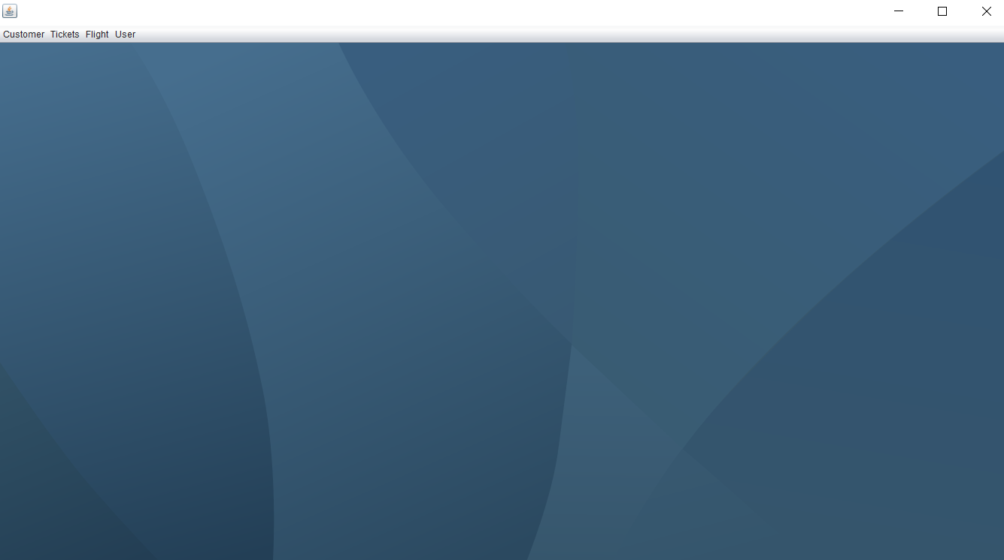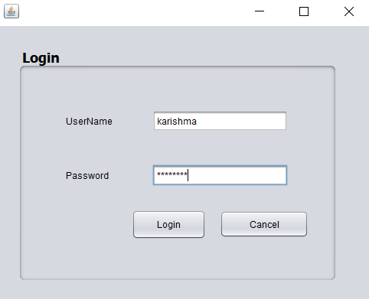

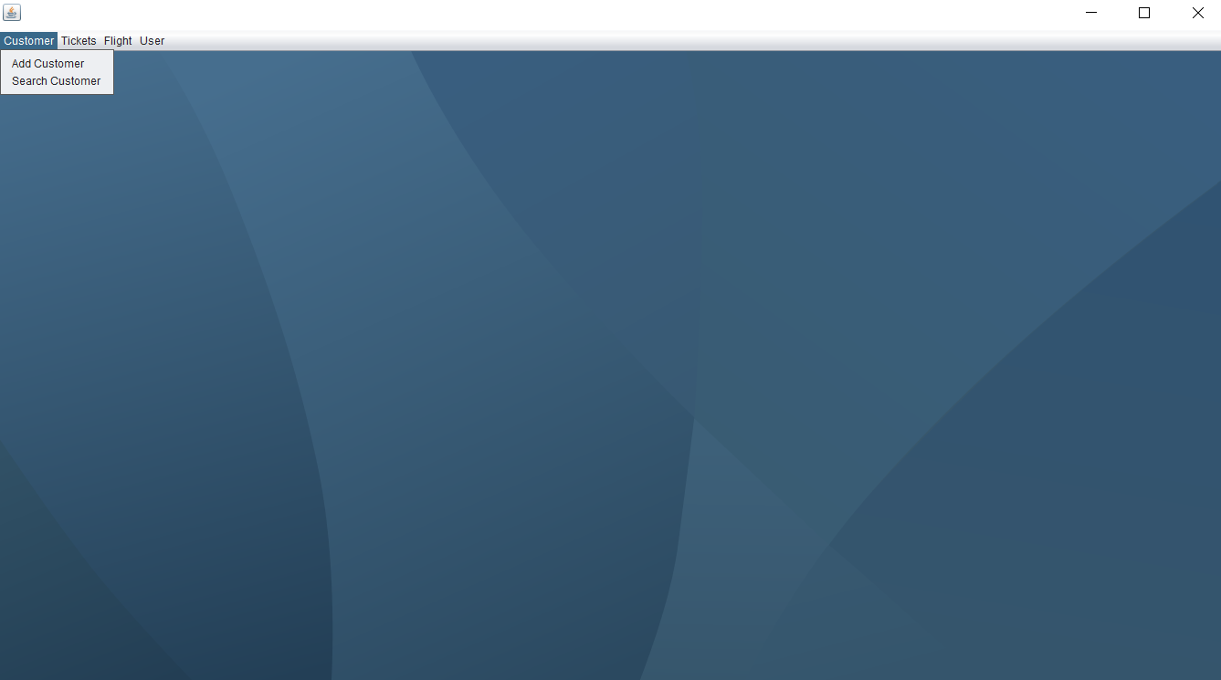

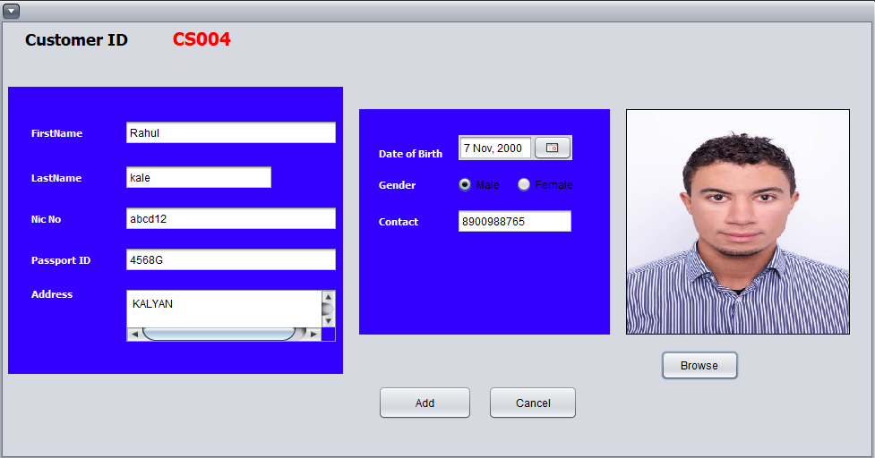

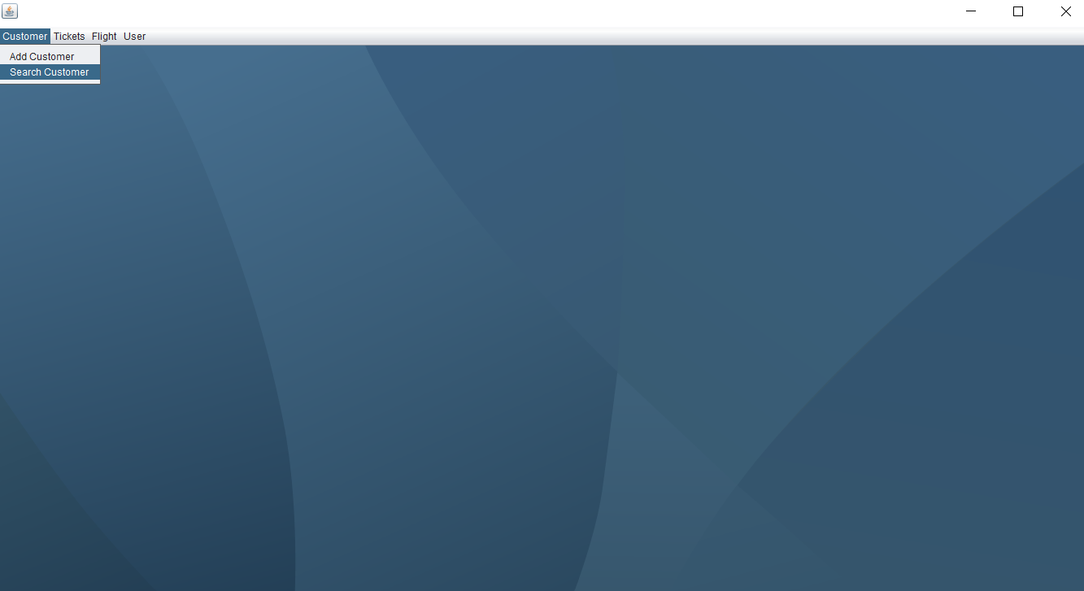

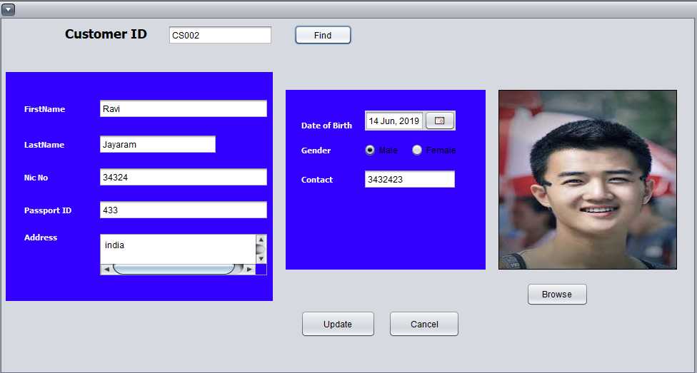

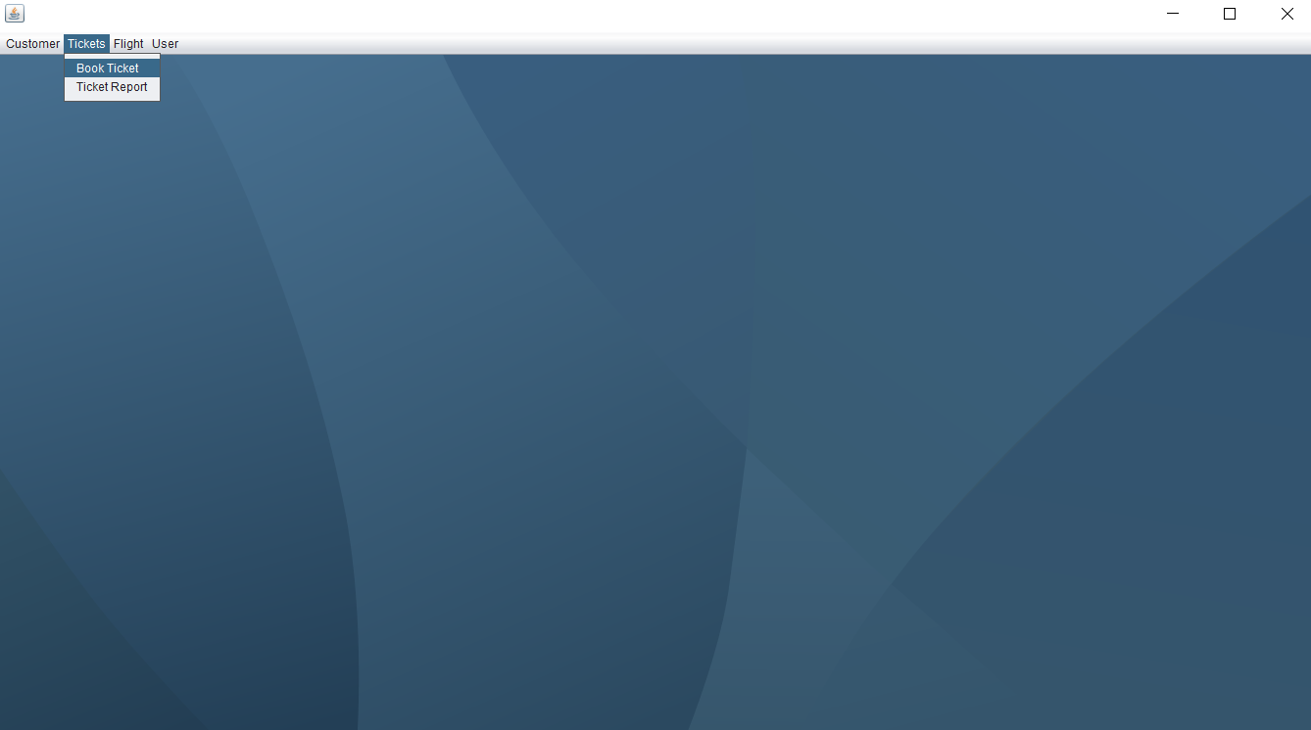

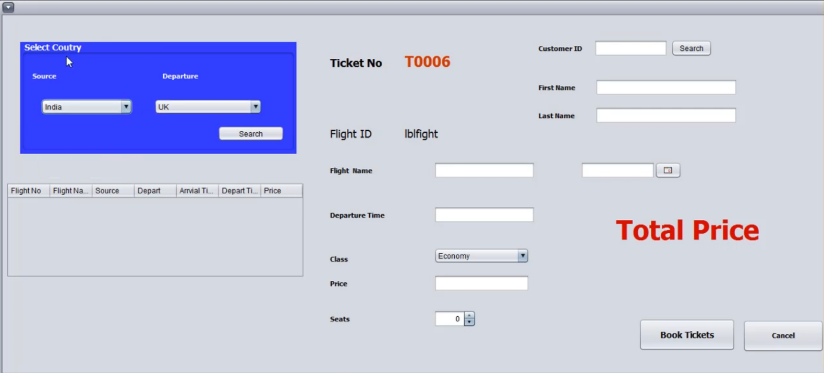

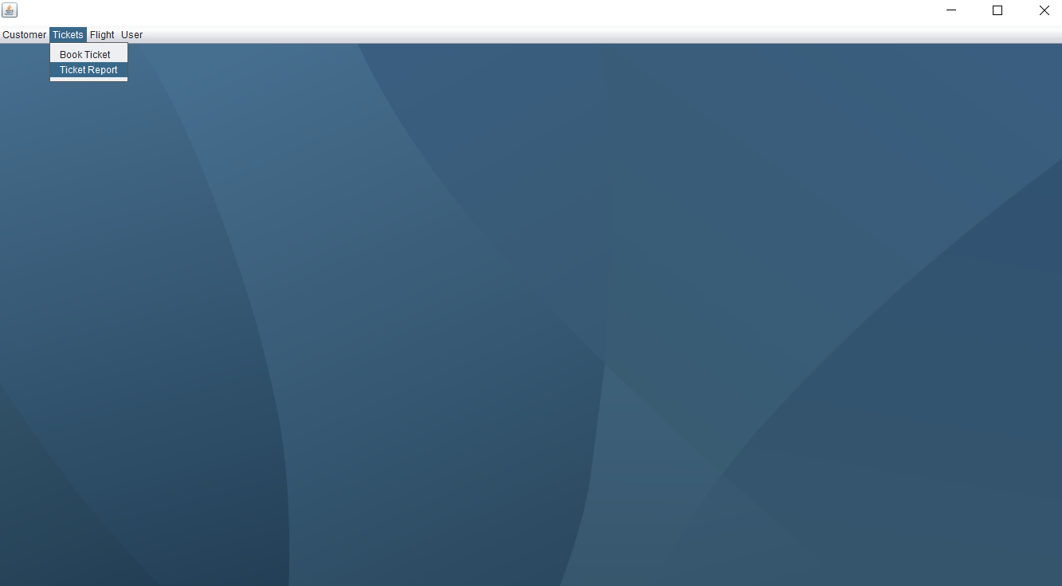

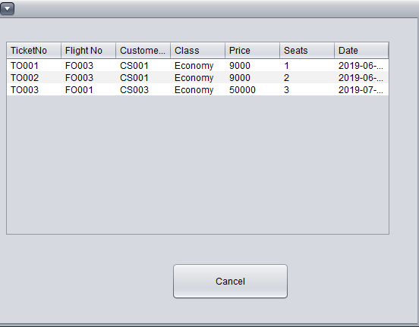

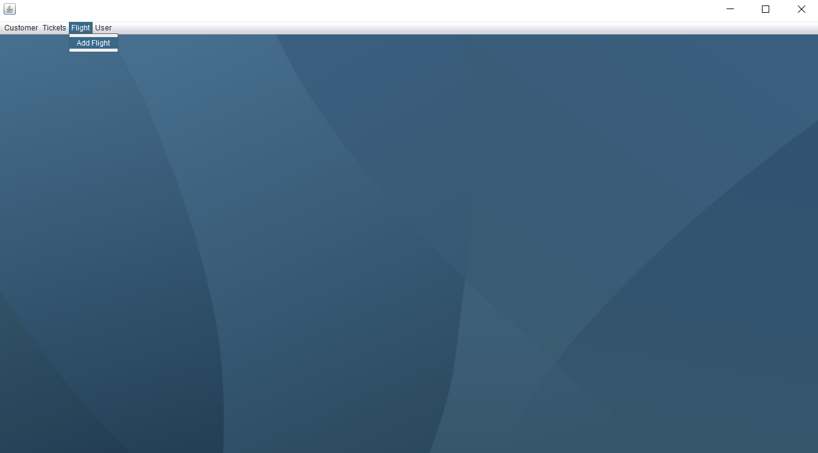

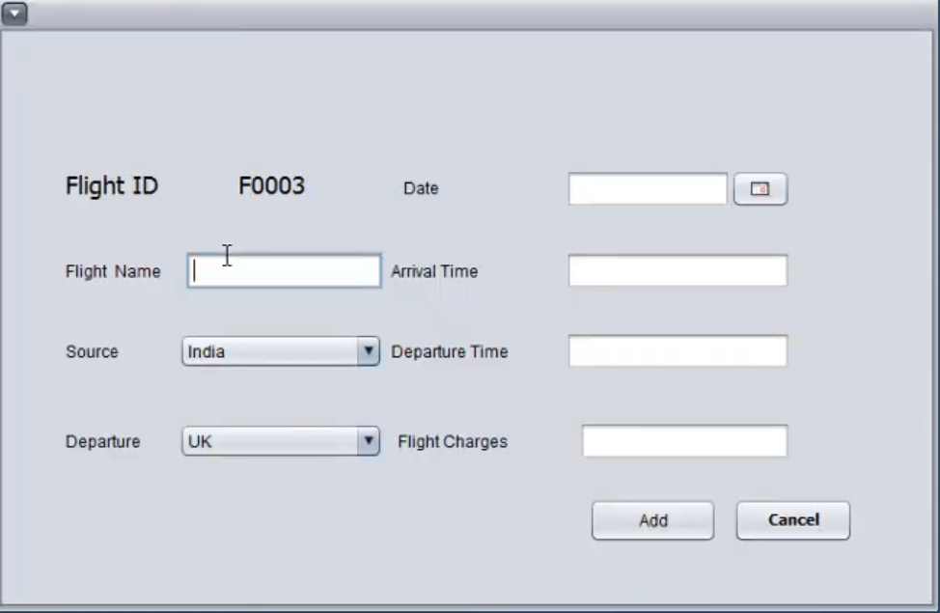

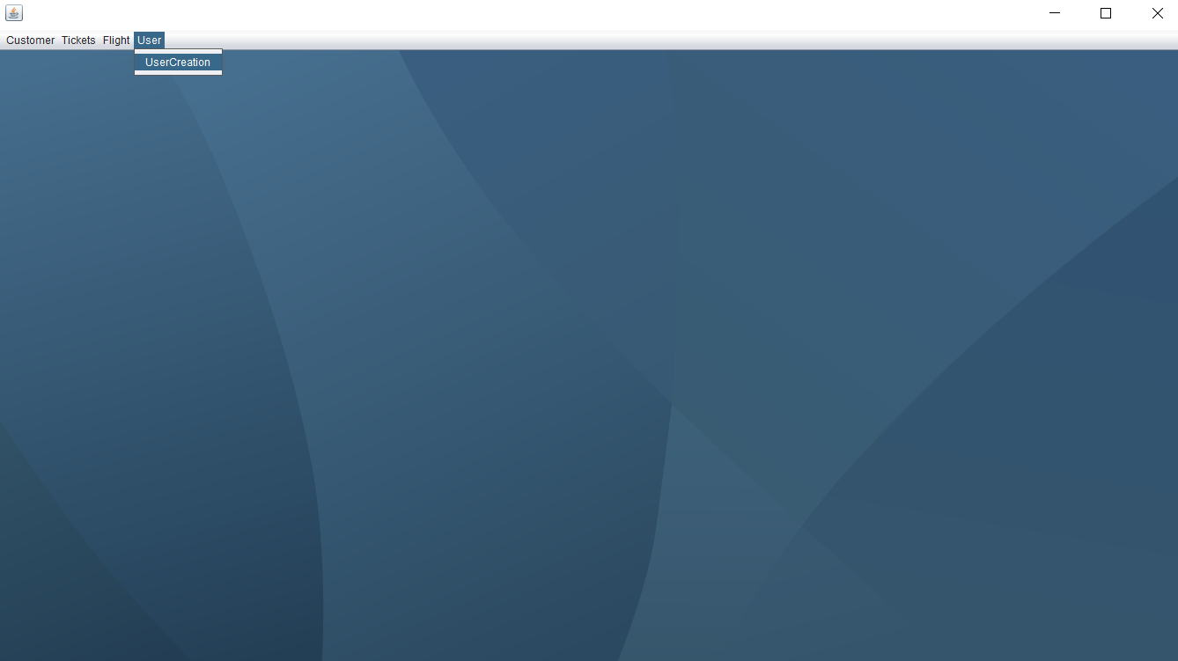

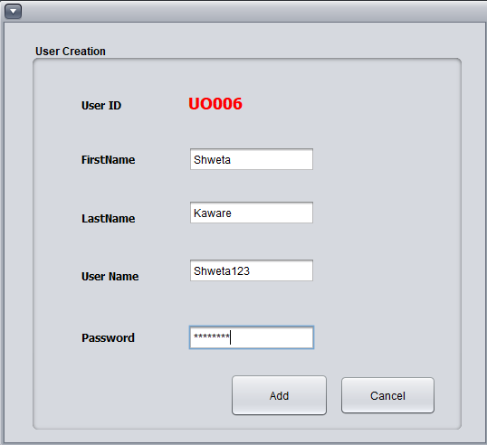

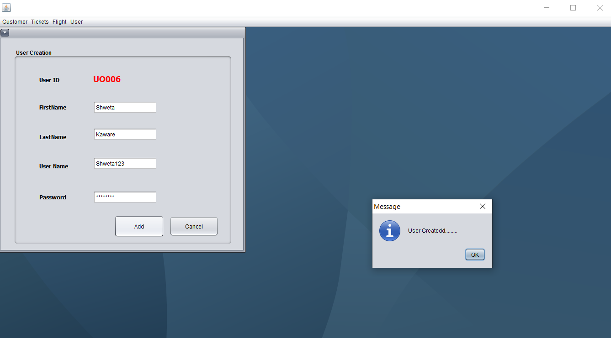

**Chapter 4**

**Conclusion**

This Online Airline Reservation System Project is a software designed to help the Airline System employees to issue reservation tickets for various air flights. It maintains the records of various passengers and provide quick services to the passengers. This software speeds up the reservation system and make it convenient for passengers to book the flight whenever and wherever they want. It reduces the scope of manual error and conveniently maintains any modifications and cancellation in the reservations. It not only provides flight details but also creates platform to book tickets, cancels or modifies ticket timing or date. The system follows a simple process which allows the passenger to check availability of flights by entering the two travel cities, namely the “Departure city” and “Arrival city”. Once this is done if the seats are available the system asks the customer to enter his details such as name, address, city, state, credit card number and contact number. Then it checks the validity of card and book the flight and update the airline database and user database.

The major functions include:

• Providing flight details

• Flight bookings for a particular destination, date and time and also providing with a pin code.

• Allowing the customer to modify or cancel his reservation provided the correct pin code is given.

• Displaying a report of the number of people flying in a particular flight.

**Reference**

1) <https://github.com/kunaltyagi9/Airline-Management-System>

2) <https://www.vidyarthiplus.com/vp/Thread-Airline-Reservation-System-Mini-Project>

3) <https://www.slideshare.net/mobile/SanjanaAgarwal13/airline-reservation-report> - Problem Statement